Lipids

Biological lipids are a chemically diverse group of compounds, the common and defining feature of which is their insolubility in water. Fats and oils are the principal stored forms of energy in many organisms, phospholipids and sterols are major structural elements of biological membranes, other lipids, will function as enzyme cofactors, electron carriers, light-absorbing pigments, hydrophobic anchors, emulsifying agents, hormones, and intracellular messengers.

Storage lipids

Fatty acids are hydrocarbon derivatives
Fatty acids are carboxylic acids with hydrocarbon chains ranging from 4 to 36 carbons long (C4 to C36). In some fatty acids, this chain is fully saturated and unbranched, in others the chain contains one or more double bonds. A few contain three-carbon rings, hydroxyl groups or methyl-group branches. A simplified nomenclature for these compounds specifies the chain length and number of double bonds, separated by a colon; the position of any double bonds are specified by superscript numbers following Δ (delta). The most commonly occurring fatty acids have even numbers of carbon atoms in an unbranched chain of 12 to 24 carbons (why?). There is also a common pattern in the location of double bonds; in most monounsaturated fatty acids the double bond is between C-9 and C-10 (Δ⁹), and the other double bonds of polyunsaturated fatty acids are generally Δ¹² and Δ¹⁵. Normally, these double bonds are not conjugated and separated by a methylene group. See the structure shown in the following table.
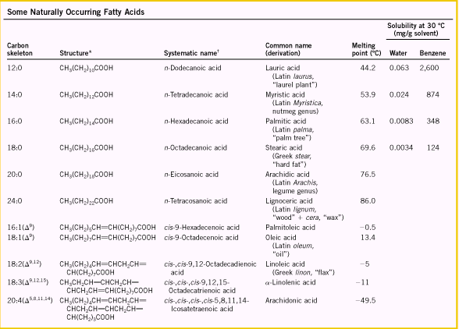
The physical properties of fatty acids are determined by the length and degree of unsaturation of hydrocarbon chain. With the same degree of saturation, the longer the chain, the higher the melting point and boiling point the fatty acid holds, and the lower the solubility in water; on the other hand, the more the double bonds in the hydrocarbon chain, the lower the melting point is (why? See page 365). And the double bond is normally in cis configuration.

Triacylglycerols are fatty acid esters of glycerol
The simplest lipids constructed from fatty acids are the triacylglycerols, also referred to as triglycerides, fats, or neutral fats. Triacylglycerols are composed of three fatty acids each in ester linkage with a single glycerol. Those containing the same kind of fatty acid in all three positions are called simple triacylglycerols and are named after the fatty acid they contain, such as tristearin, tripalmitin and triolein represent the triacylglycerol with fatty acids of stearic acids, palmitic acids and oleic acids. Explain why triacylglycerols are nonpolar (why?)
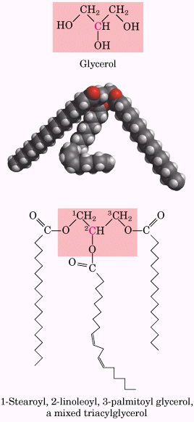
Triacylglycerols provide stored energy and insulation
In vertebrates, specialized cells called adipocytes, or fat cells, store large amounts of triacylglycerols as fat droplets that nearly fill the cell. Triacylglycerols are also stored as oils in the seeds of many types of plants, providing energy and biosynthetic precursors during seed germination. Adipocytes and germinating seeds contain lipases, enzymes that catalyze the hydrolysis of stored triacylglycerols, releasing fatty acids for export to sites where they are required as fuel.
Two significant advantages to using triacylglycerols as stored fuels rather than polysaccharides are: 1) providing more energy than polysaccharide (gram for gram), 2) not carrying extra weight of water of hydration (why?). However, the human body can store less than a day’s energy supply in the form of glycogen, as carbohydrates such as glucose and glycogen do offer certain advantages as quick sources of metabolic energy, one of which is their ready solubility in water.
In some animals, triacylglycerols stored under the skin serve not only as energy stores but as insulation against low temperatures.

Many foods contain triacylglycerols
Vegetable oils such as corn (maize) and olive oil are composed largely of triacylglyceorls with unsaturated fatty acids and thus are liquids at room temperature.
Waxes serve as energy stores and water repellents

Another kind of lipids are called waxes, which are esters of long-chain (C14 to
C36) saturated and unsaturated fatty acids with long-chain (C16 to C30) alcohols. Their melting points (60 to 100 C) are generally higher than those of triacylglycerols.
Waxes also serve a diversity of other function in nature related to their water-repellent properties and their firm consistency, and are widely used in the pharmaceutical, cosmetic and other industries, such as lotions, ointments and polishes.

Structural lipids in membranes
The central architectural feature of biological membranes is a double layer of lipids, which acts as a barrier to the passage of polar molecules and ions. Membrane lipids are amphipathic; one end of the molecule is hydrophobic, the other hydrophilic. Their hydrophobic interactions with each other and their hydrophilic interactions with water direct their packing into sheets called membrane bilayers. There are three major membrane lipids: 1) glycerophospholipids, in which the hydrophobic regions are composed of two fatty acids joined to glycerol; 2) sphingolipids, in which a single fatty acid is joined to a fatty amine, sphingosine; and 3) sterols, compounds characterized by a rigid system of four fused hydrocarbon rings. In glycerophospholipids and some sphingolipids, a polar head group is joined to the hydrophobic moiety by a phosphodiester linkage; these kinds of lipids are called phospholipids. Other sphingolipids lack phosphate but have a simple sugar or complex oligosaccharide at their polar ends, are called glycolipids.
The membrane lipids are summaried below.
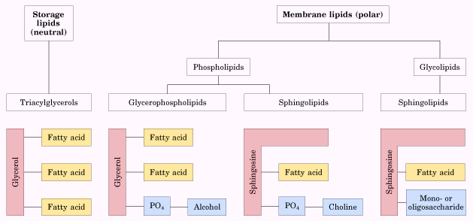
Glycerophospholipids are derivatives of Phosphatidic acid
Glycerophospholipids, also called phosphoglycerides, are membrane lipids in which two fatty acids are attached in ester linkage to the first and second carbons of glycerol, and a highly polar or charged group (head group) is attached through a phosphodiester linkage to the third carbon. In this kind of lipids, phosphate group bears a negative charge at neutral pH. The polar alcohol may be negatively charged as in phosphatidylinositol 4,5-bisphosphate), neutral (phosphatidylserine), or positively charged (phosphatidylcholine, phosphatidylethanolamine). In general, glycerophospholipids contain a C16 or C18 saturated fatty acid at C-1 and a C18 to C20 unsaturated fatty acid at C-2.
The structure of phospholipids are shown as follows.
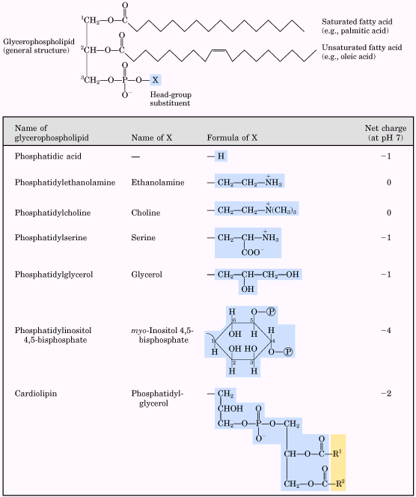
Some phospholipids have ether-linked fatty acids
Some animal tissues and some unicellular organisms are rich in ether lipids, in which one of the two acyl chains is attached to glycerol in ether, rather than ester linkage. The ether-linked chain may be saturated, as in the alkyl ether lipids, or may contain a double bond between C-1 and C-2, as in plasmalogens. Vertebrate heart tissue is uniquely enriched in ether lipids. Some examples are shown as follows.
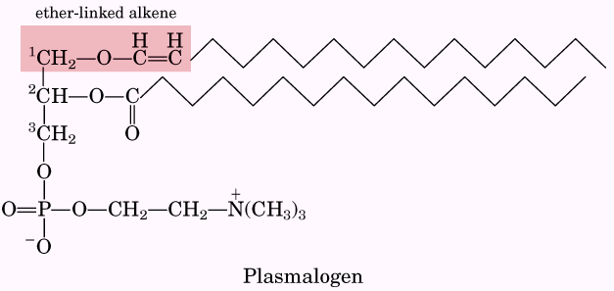 | 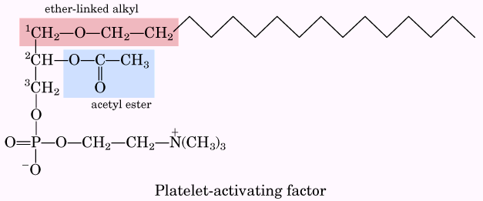

Sphingolipids are derivatives of sphingosine
Sphingolipids, the second large class of membrane lipids, also have a polar head group and two nonpolar tails, but unlike glycerophospholipids they contain no glycerol. Sphingolipids are composed of one molecule of the long-chain amino alcohol sphingosine (4-sphingenine) or one of its derivatives, one molecule of a long-chain fatty acid, and a polar head group that is joined by a glycosidic linkage in some case and by a phosphodiester in others. When a fatty acid is attached in amide linkage to the –NH₂ on C-2, the resulting compound is a ceramide, which is the parent molecule of all sphingolipids.
There are three subclasses of sphingolipids, all derivatives of ceramide but differing in their head groups: sphingomyelins, neutral (uncharged) glycolipids, and gangliosides. Sphingomyelins contain phosphocholine or phosphoethanolamine as their polar head group and are therefore classified along with glycerophospholipids as phospholipids.
Glycosphingolipids, which occur largely in the outer face of plasma membranes, have head groups with one or more sugars connected directly to the –OH at C-1 of the ceramide moiety; they do not contain phosphate. Cerebrosides have a single sugar linked to ceramide; those with galactose are characteristically found in the plasma membranes of cells in neutral tissue, and those with glucose in the plasma membranes of cells in nonneutral tissues. Globosides are neutral (uncharged) glycosphingolipids with tow or more sugars, usually D-glucose, D-galactose, or N-acetyl-D-galactosamine. Cerebrosides and globosides are sometimes called neutral glycolipids, as they have no charge at pH 7.
Gangliosides, the most complex sphingolipids, have oligosaccharides as their polar head groups and one or more residues of N-acetylneuraminic acid (Neu5Ac), also called sialic acid, at the termini. Gangliosides with one sialic acid residues are in the GM (M for mono-) series, those with two sialic acids are in the GD (D for di-) series. Some structures are listed as follows.

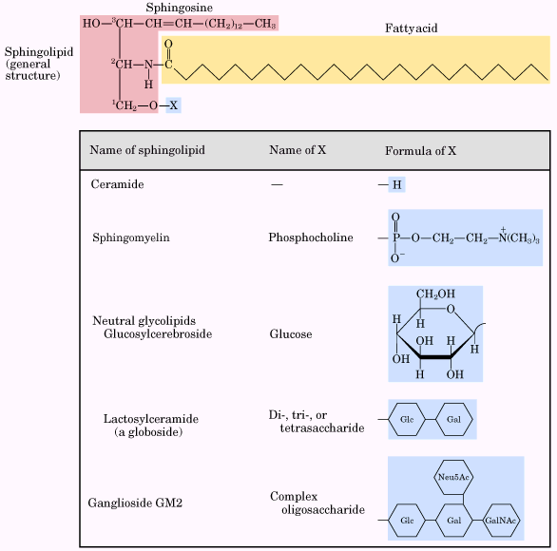

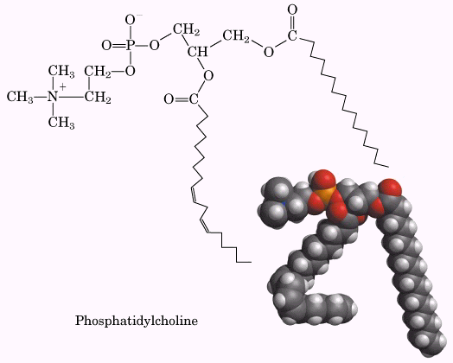 | 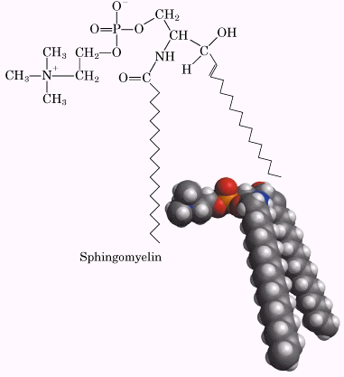
Sphingolipids at cell surfaces are sites of biological recognition
Phospholipids and sphingolipids are degraded in lysosomes
Phospholipases, a specific hydrolytic enzyme in the lysosome, will degrade the membrane lipids. Type A phospholipase remove one of the two fatty acids, producing a lysophospholipid. (these esterases do not attack the ether link of plasmalogens). Lysophospholipases removed the remaining fatty acid.
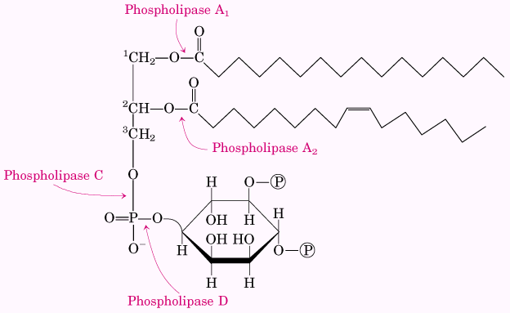 | 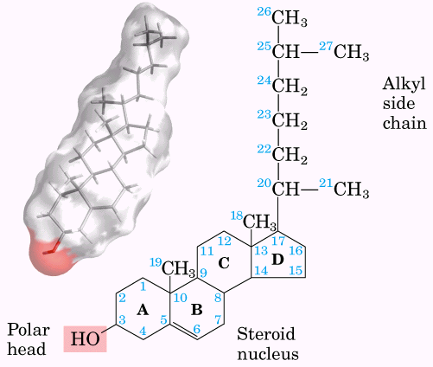
Sterols have four fused carbon rings
Sterols are structural lipids present in the membranes of most eukaryotic cells. Their characteristic structure is the steroid nucleus consisting of four fused rings, three with six carbons and one with five. The steroid nucleus is almost planar and is relatively rigid; the fused rings do not allow rotation about C-C bonds. Cholesterol, the major sterol in animal tissues, is amphipathic, with a polar head group (the hydroxyl group at C-3), and a nonpolar hydrocarbon body (the steroid nucleus and the hydrocarbon side chain at C-17) about as long as a 16-carbon fatty acid in its extended form.
In addition to their roles as membrane constituents, the sterols serve as precursors for a variety of products with specific biological activities, such as hormones.

Lipids as signals, cofactors and pigments

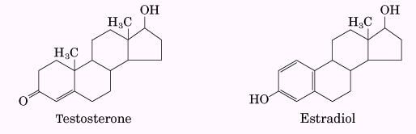 | 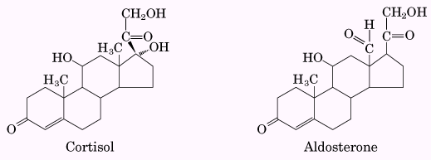 | 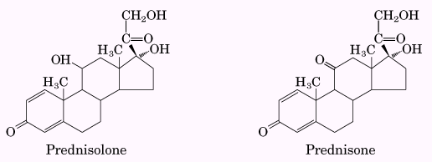

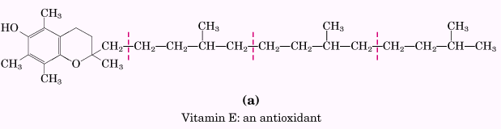 | 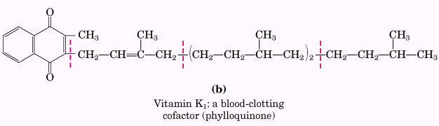
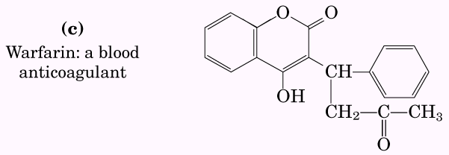 | 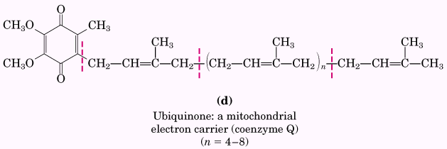
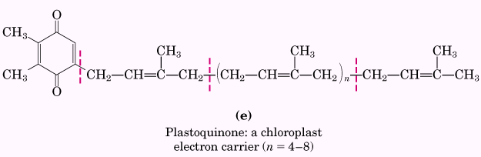 | 