Enzyme

The character of enzyme is its super-active capability to accelerate chemical reactions in biological systems, and other systems. For example, sugar are stable for years, however, it can be consumed by human in seconds, by means of oxidation to CO₂ and H₂O. The highly active catalytic ability of enzyme is much more efficient than that of inorganic or synthetic catalyst. In addition, different enzymes can work together, and catalyze a multistep reaction, of which each step is catalyzed by an individual enzyme. In biological systems, almost all chemical reactions are catalyzed by enzymes, such as the energy transformation, the degradation of nutrient, and the synthesis of biomolecules and so on. By the way, many kind of inheritable genetic diseases are related to the dysfunction of enzymes or in the absence of certain enzyme.

An introduction to enzymes

A brief description about the history of enzyme study is helpful. In 1850s, Louis Pasteur in France found that sugar can change into alcohol by fermentation with yeast, and he called the catalyst of yeast “ferments”, unfortunately, he thought that the ferments could not be separated from the structure of living yeast cells. In 1897, Eduard Buchner found that the yeast extracts continued to function when they were removed from yeast cells, and he proved that the ferments are kind of molecules, called as “enzymes”. This discovery is very important, because this total changed the concept or idea about how do we understand about the enzymes, after that the studies on enzymes are accelerated also. In 1926, James Sumner isolated first enzyme, i.e., urease, and he found out that the structure of this enzyme is entirely protein, so he postulated that the enzymes were all proteins. This theory was proven by later studies on other enzymes, such as pepsin, trypsin, and other digestive enzymes.

Most enzymes are proteins
Except for a small group of catalytic RNA, all enzymes are proteins. Like other proteins, the catalytic activity of enzymes are highly depended on their structure and conformations; when conformation is denatured or the structure is broken down into subunits, the activity is lost also.
The size of enzymes is around 12,000 to millions. Of these enzymes, some of them can work alone, but a large fraction of these enzymes must work together with an additional component, called a cofactor---- either one or more inorganic ions, such as Fe²⁺, Mn²⁺, Mg²⁺, Zn²⁺ (see table 1), or a complex organic or metalloorganic molecules called coenzyme (see table 2). Some enzymes even require both a coenzyme and one or more metal ion for activity. A coenzyme or metal ion that is very tightly or even covalently bound to the enzyme protein is called a prosthetic group. A complete, catalytically active enzyme together with its bound coenzyme and/or metal ions is called a holoenzyme. The protein part of such an enzyme is called the apoenzyme or apoprotein. Some enzymes are modified covalently by phosphorylation, glycosylation to further regulate the activity of these enzymes.
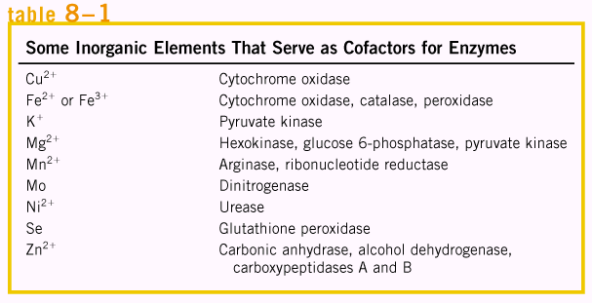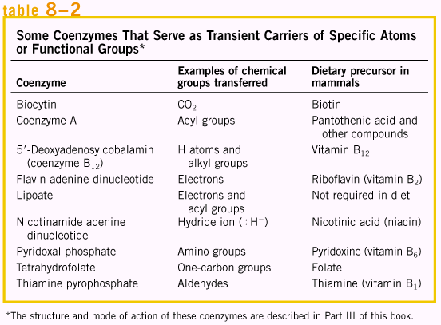

Enzymes are classified by the reactions they catalyze
Many enzymes have been named by adding the suffix “-ase” to the name of their substrate or to a word or phrase describing their activity. Thus urease catalyzes hydrolysis of urea, and DNA polymerase catalyzes the polymerization of nucleotides to form DNA. This kind of name system is very confusing, so, biochemists use more accurate method to differentiate these enzymes. Normally, enzymes are divided into six major classes, each with subclasses, based on the type of reaction catalyzed. (See table 3). Each enzyme is assigned a four-digit classification number and a systematic name, which identifies the reaction it catalyzes.
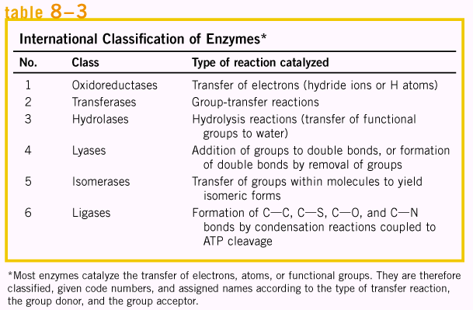

How enzymes work

An enzyme circumvents activation barrier by providing a specific environment within which a given reaction is energetically more favorable. The distinguishing feature of an enzyme-catalyzed reaction is that it occurs within the confines of a pocket on the enzyme called the active site. The molecule that is bound in the active site and acted upon by the enzyme is called the substrate.

Enzymes affect reaction rates, not equilibria
A simple enzymatic reaction might be written as:
8-1
Where E, S and P stands for enzyme, substrate and product respectively. ES and EP are transient complexes of the enzyme with the substrate and with the product.
Remember, catalyst only increases the reaction rate, does not affect reaction equilibria. For a simple reaction such as S ↔ P, the reaction coordination diagram can be shown as in Fig 1, the starting point for either the forward or the reverse reaction is called the ground state, the contribution to the free energy of the system by an average molecule (S or P) under a given set of conditions. The standard free-energy change ΔG° is the free energy difference from starting material to product at certain conditions, i.e. at temperature of 298 K, partial pressure of each gas at 1 atm or 101.3 kPa, and concentration of each solute at 1M. Biochemical standard free-energy change ΔG’° is the standard free-energy change at pH 7.0.

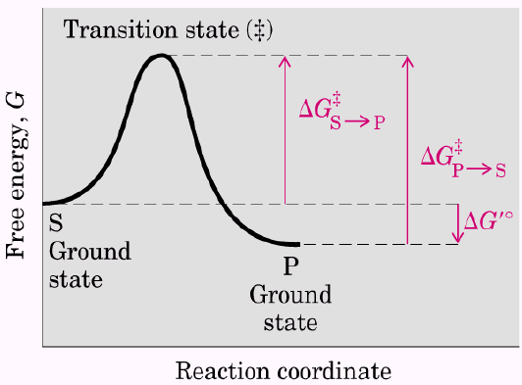  Fig. 1 Reaction coordinate diagram for a chemical reaction | 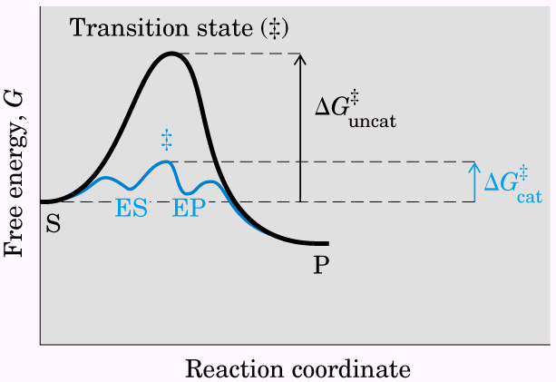  Fig. 2 Reaction coordinate diagram comparing enzyme-catalyzed and uncatalyzed reactions.
As shown in Fig. 1, from starting material to product, the highest point in terms of energy is called transition state, and the energy difference between the starting material and transition state is called activation energy. If product has lower free energy than starting material, the reaction from starting material to product is favorable; in other word, if the ΔG’° is negative, the reaction is thermodynamic favorable. However, a favorable reaction does not mean it can happen spontaneously, the controlling factor is the activation energy (ΔG≠). Increasing the temperature can speed up the reaction, by means of increasing the kinetic energy of starting material, to increase the number of starting material molecules with higher energy than the transition state. Enzyme can lower the activation energy by means of providing specific binding site, where the starting material is more close to each other and the conformation is orientated to facilitate the reaction. As shown in Fig. 2, after forming complex between starting material and enzyme, the energy of complex is lowered, so the reaction is increased. The enzyme complex is called intermediate. It is very clear that when enzyme lowers the activation energy from starting material to product, and it also lowers the activation energy from product to starting material. So, when enzyme accelerates the reaction, it accelerates the reverse reaction also. Therefore, enzyme does not affect equilibria, but accelerates the reaction rate. The energy curve from starting material to product is called reaction pathway. In this reaction pathway, if more than one intermediate exists, the individual step reaction to reach the intermediate with highest energy will limit the reaction rate, and this step of reaction is called rate-limiting step, or rate-determining step.

Reaction rates and equilibria have precise thermodynamic definitions
Reaction equilibria are inextricably linked to ΔG’°, and reaction rates are linked to ΔG≠. For an equilibrium in a simple reaction such as:
8-2
K’_{eq} stands for the equilibrium constant under the standard conditions.
ΔG’° = -RT ln K’_{eq} 8-3
Where R is the gas constant, 8.314 J/mol.K, and T is the absolute temperature. A large negative value for ΔG’° reflects a favorable reaction equilibrium, but as already noted, this does not mean the reaction will proceed at a rapid rate.
The rate of any reaction is determined by the concentration of the reactant and by a rate constant, usually denoted by k. For the reaction shown in equation 8-2, we have:
V = k[S] 8-4
From transition-state theory, the rate is determined by the activation energy:
$k=\frac{κT}{ℏ}e^{{−{ΔG}^{}}/{\text{RT}}}$ 8-5
Where $κ$ is the Boltzmann constant and $ℏ$ is Planck’s constant. As you can see from equation 8-5, the relationship between the rate constant and the activation energy ΔG≠ is inverse and exponential. Some equilibria and rate constants about enzymes are listed in Table 4 and 5 respectively.
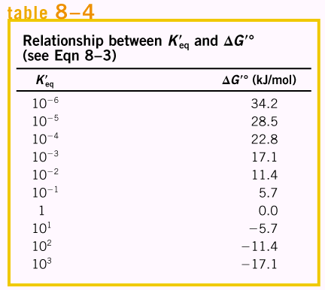 | 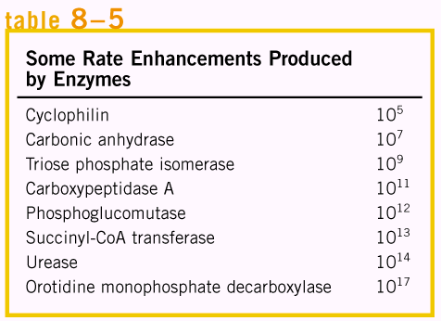

A few principles explain the catalytic power and specificity of enzymes
Enzymes are extraordinary catalysts; the rate enhancements brought about by enzymes are in the range of 5 to 17 orders of magnitude. In addition, enzymes are also very specific, readily discriminating between substrates with quite similar structures. The roles of enzyme in catalysis is: 1) rearrangements of covalent bonds during an enzyme catalyzed reaction, i.e., catalytic functional groups on an enzyme may form a transient covalent bond with a substrate and activate it for reaction or some group may be transiently transferred from the substrate to a group on the enzyme. 2) Noncovalent interaction between enzyme and substrate. Formation of each weak interaction in the ES complex is accompanied by a small release of free energy that provides a degree of stability to the interaction. The energy derived from enzyme-substrate interaction is called binding energy, ΔG_{B}. Binding energy is a major source of free energy used by enzymes to lower the activation energies of reactions, and this energy contributes to specificity as well as catalysis. Furthermore, weak interactions are optimized in the reaction transition state, because enzyme active sites are complementary to the transition state.

Weak interactions between enzyme and substrate are optimized in the transition state
Enzyme can bind the substrate, however, the complete complementary binding happens in the transition states, otherwise, the perfect match from enzyme and substrate will retard the reaction, as shown in the following depict, where the breakage of metal stick happens. Certain energy must be provided so that the metal stick can bend (to reach its transition energy) before it breaks. If a perfect magnet fits the shape of metal stick, and it is difficult for metal stick to break, because the magnet must change its conformation also, in this case, the activation energy is increased. So the real situation for the catalysis from enzyme is that the enzyme can bind the substrate in certain degree, but not perfect; this will provide subtle energy for the binding. Then as the reaction goes on, the metal stick bend exactly to fit the shape of magnet, and the energy need to bend and break the metal stick is compensated by the close interaction between the metal stick and magnet. Similarly, in enzyme catalysis, some weak interactions are formed in the ES complex, but the full complement of such interactions between substrate and enzyme are formed only when the substrate reaches the transition state. The free energy (binding energy) released by the formation of these interactions partially offsets the energy required to reach the top of the energy hill. The summation of the unfavorable (positive) activation energy ΔG≠ and the favorable (negative) binding energy ΔG_{B} results in a lower net activation energy.
The important principle is that the weak-bonding interactions between the enzyme and the substrate provide a major driving force for enzymatic catalysis. The groups on the substrate that are involved in these weak interactions can be at some distance from the bonds that are broken or changed. The weak interactions formed only in the transition state are those that make the primary contribution to catalysis.
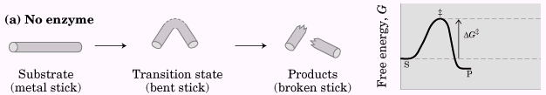 Role of binding energy in catalysis.
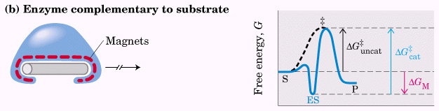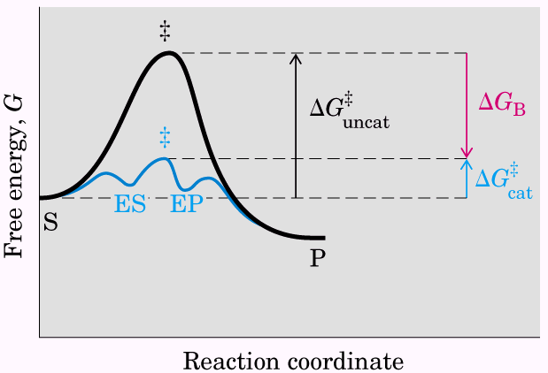
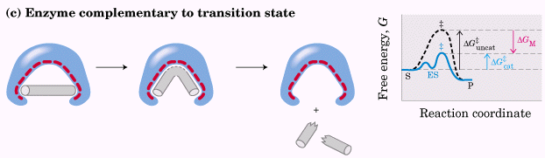

Binding energy contributes to reaction specificity and catalysis
The same binding energy that provides energy for catalysis also gives an enzyme its specificity, the ability to discriminate between a substrate and a competing molecule. Specificity is derived from the formation of multiple weak interactions between the enzyme and its specific substrate molecule.
Binding energy is the dominant driving force in several mechanisms and can be the major, and sometimes the only, contributor to catalysis.
A large reduction in the relative motions of two substrates that are to react, or entropy reduction, is one obvious benefit of binding them to an enzyme. Binding energy holds the substrates in the proper orientation to react --- a major contribution to catalysis because productive collisions between molecules in solution can be exceedingly rare. Substrates can be precisely aligned on the enzyme, with a multitude of weak interactions between each substrate and strategically located groups on the enzyme clamping the substrate molecules into the proper positions.

Formation of weak bonds between substrate and enzyme also results in desolvation of the substrate.
A sample showing the reduction of entropy to the enhancement of reaction rate is shown as follows.
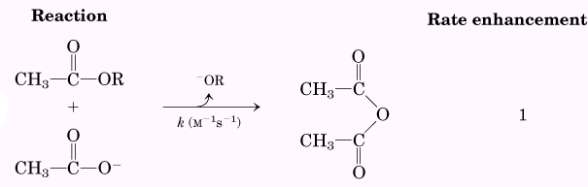 | 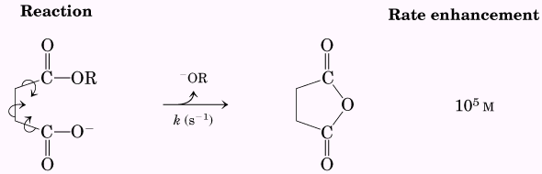
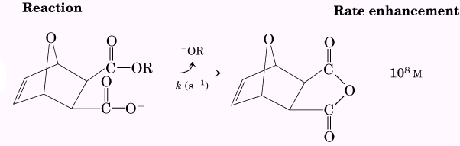

Specific catalytic groups contribute to catalysis
The catalytic mechanisms include general acid-base catalysis, covalent catalysis and metal ion catalysis. These mechanisms are differentiated from each other based on the binding energy.

General acid-base catalysis
Many biochemical reactions involve the formation of unstable charged intermediates that tend to break down rapidly to their constituent reactant species, thus impeding the reaction. Charged intermediates can often be stabilized by the transfer of protons to or from the substrate or intermediate to form a species that breaks down more readily to products than to reactants. Catalysis of this type that uses only the H⁺ (H₃O⁺) or OH⁻ ions present in water is referred to as specific acid-base catalysis. The term general acid-base catalysis refers to proton transfers mediated by other classes of molecules, instead of water.
Covalent catalysis
A transient covalent bond is formed between the enzyme and the substrate, such as the hydrolysis reaction as follows:
This alters the pathway of the reaction and results in catalysis only when the new pathway has lower activation energy than the uncatalyzed pathway. Both of the new steps must be faster than the uncatalyzed reaction.
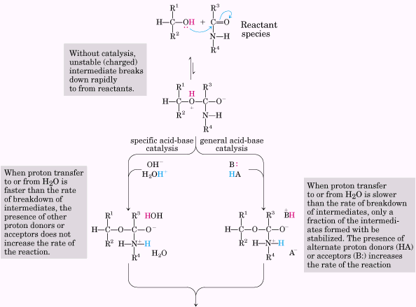
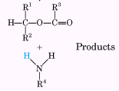
Amino acids in general acid-base catalysis
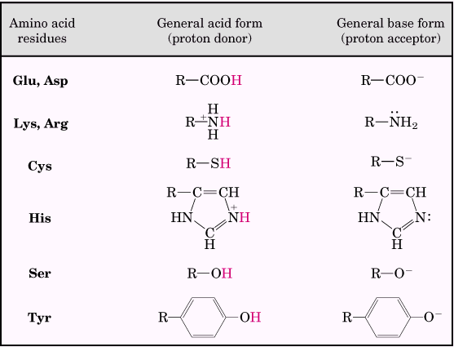

Metal ion catalysis
Metals, whether tightly bound to the enzyme or taken up from solution along with the substrate, can participate in catalysis in several ways, such as ionic interaction, oxidation-reduction and so on. Nearly a third of all known enzymes require one or more metal ions for catalytic activity.
Most enzymes employ a combination of several catalytic strategies to bring about a rate enhancement.

Enzyme kinetics as an approach to understanding mechanism
Enzyme kinetics is to study the mechanism of an enzyme-catalyzed reaction, to determine the rate of the reaction and how it changes in response to changes in experimental parameters.

Substrate concentration affects the rate of enzyme-catalyzed reactions
A key factor affecting the rate of a reaction catalyzed by a purified enzyme in vitro is the concentration of substrate, [S].
Initial rate (or initial velocity), designated V₀, is the reaction rate when [S] is generally much greater than the concentration of enzyme, [E]. The more the substrate, the faster the rate is; however, at higher substrate concentration, V₀ increases by smaller and smaller amounts in response to increases in [S]. Finally, a point is reached beyond which increases in V₀ are vanishingly small as [S] increases. This plateau-like V₀ region is close to the maximum velocity, V_{max}.
The combination of an enzyme with its substrate molecule to form an ES complex is a necessary step in enzyme catalysis. In other words, enzyme first combines reversibly with its substrate to form an enzyme-substrate complex in a relatively fast reversible step:
8-6
The ES complex then breaks down in a slower second step to yield the free enzyme and the reaction product P:
8-7
The overall rate is proportional to the concentration of the species that reacts in equation 8-7, which is a rate-limiting step. At any given instant in an enzyme-catalyzed reaction, the enzyme exists in two forms, the free or uncombined for E and the combined for ES. At low [S], most of the enzymes are in the uncombined form E and hence the rate is proportional to [S] because the equilibrium of equation 8-6 is pushed toward formation of more ES as [S] is increased.
When the enzyme is first mixed with a large excess of substrate, there is an initial period, the pre-steady state, during which the concentration of ES builds up. This period is usually too short to be easily observed. The reaction quickly achieves a steady state in which [ES] (and the concentrations of other intermediates) remains approximately constant over time. The measured V₀ generally reflects the steady state even though V₀ is limited to early in the course of the reaction, and analysis of these initial rates is referred to as steady-state kinetics.

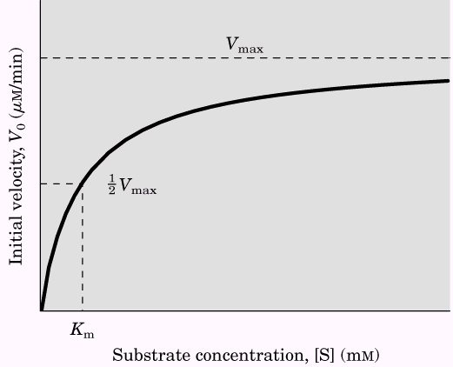
Effects of substrate concentration on the initial velocity of an enzyme-catalyzed reaction.
The relationship between substrate concentration and reaction rate can be expressed quantitatively
A few steps of algebraic variation can give us the equation to quantify the kinetic rate of enzyme during the catalysis. Because the enzyme complex can reversibly release the substrate, and it can also lead to product, the first assumption is that the binding of enzyme with product to form the enzyme complex is negligible, so we have the equation as:
8-8
The V₀ is determined by the breakdown of ES to form product, which is proportional to [ES]
V₀ = k₂[ES] 8-9
If [ES] is known, then V₀ is easily presented by equation 8-9; however, the problem here is to quantify the concentration of [ES], and it is very difficult to do so, therefore, we introduce the term [E_{t}], representing the total enzyme concentration, thus the concentration of free enzyme can be represented by [E_{t}] – [ES].
As this reaction is steady-state, that means the concentration of [ES] will be kept constantly during the reaction, thus the rate to form new ES will be identical to the rate of ES's disappearance. So, we have the equation
k₁ ([E_{t}] – [ES])[S] = k₋₁[ES] + k₂ [ES] 8-10
The left side is multiplied out and the right side is simplified as:
k₁[E_{t}][S] – k₁[ES][S] = (k₋₁ + k₂)[ES] 8-11
k₁[E_{t}][S] = (k₁[S] + k₋₁ + k₂)[ES] 8-12
$[\text{ES}]=\frac{k_{1}[E_{t}][S]}{k_{1}[S]+k_{−1}+k_{2}}$ 8-13
This can be simplified further, combining the rate constant into one expression:
$[\text{ES}]=\frac{[E_{t}][S]}{[S]+\frac{k_{2}+k_{−1}}{k_{1}}}$ 8-14
The term (k₂ + k₋₁)/k₁ is defined as the Michaelis constant, K_{m}. Substituting K_{m} into equation 8-14, simplifies the expression to:
$[\text{ES}]=\frac{[E_{t}][S]}{K_{m}+[S]}$ 8-15
So now, V₀ can be expressed in terms of [ES].
$V_{0}=k_{2}[\text{ES}]=\frac{k_{2}[E_{t}][S]}{K_{m}+[S]}$ 8-16
Because the maximum velocity occurs when the enzyme is saturated, where [ES] = [E_{t}], V_{max} can be defined as k₂[E_{t}]. So
$V_{0}=\frac{V_{\text{max}}[S]}{K_{m}+[S]}$ 8-17

This is the Michaelis-Menten equation, the rate equation for a one-substrate enzyme-catalyzed reaction. It is a statement of the quantitative relationship between the initial velocity V₀, the maximum initial velocity V_{max}, and the initial substrate concentration [S], all related through the Michaelis constant K_{m}.
When V₀ is exactly one-half V_{max}, then we will have
$\frac{V_{\text{max}}}{2}=\frac{V_{\text{max}}[S]}{K_{m}+[S]}$ 8-18
which means K_{m} = [S], when V₀ = ½ V_{max}
This represents a very useful, practical definition of K_{m}: K_{m} is equivalent to the substrate concentration at which V₀ is one-half V_{max}.
However, the Michaelis-Menten equation is not that useful in practice, instead, Lineweaver-Burk equation is used most, because the later provide more accuracy in experiments. Lineweaver-Burk equation can be derived from Michaelis-Menten equation by taking the reciprocal of both sides of Michaelis-Mention equation.
$\frac{1}{V_{0}}=\frac{K_{m}+[S]}{V_{\text{max}}[S]}=\frac{K_{m}}{V_{\text{max}}[S]}+\frac{[S]}{V_{\text{max}}[S]}$ 8-19
Which simplified to
$\frac{1}{V_{0}}=\frac{K_{m}}{V_{\text{max}}[S]}+\frac{1}{V_{\text{max}}}$ 8-20
For enzymes obeying the Michaelis-Menten relationship, a plot of 1/V₀ versus 1/[S] yields a straight line; this line has a slope of K_{m}/V_{max}, an intercept of 1/V_{max} on the 1/V₀ axis, and an intercept of –1/K_{m} on the 1/[S] axis. The double-reciprocal presentation, also called a Lineweaver-Burk plot, has the great advantage of allowing a more accurate determination of V_{max}, which can only be approximated from a simple plot of V₀ versus [S] according to Michaelis-Menten equation.
Both Michaelis-Menten equation and Lineweaver-Burk equation are depicted as follows.
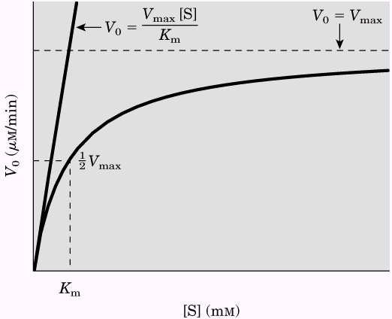  Dependence of initial velocity on substrate concentration represented by Michaelis-Menten equation. | 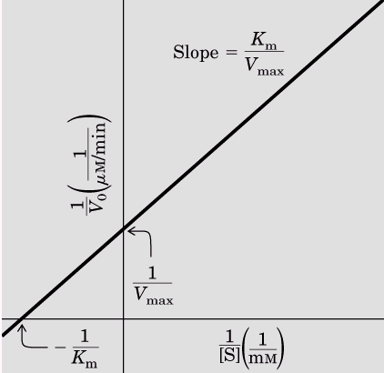  A double-reciprocal or Lineweaver-Burk plot.

Kinetic parameters are used to compare enzyme activities
The practical rule that K_{m} = [S] when V₀ = ½ V_{max} holds for all enzymes that follow Michaelis-Menten kinetics except for the regulatory enzymes. However, the Michaelis-Menten equation does not depend on the relatively simple two-step reaction mechanism proposed by Michaelis and Menten. Equation 8-17 holds true for many enzymes, both the magnitude and the real meaning of V_{max} and K_{m} can differ from one enzyme to the next. This is an important limitation of the steady-state approach to enzyme kinetics.
For reactions with two steps, K_{m} = (k₂ + k₋₁)/k₁, when k₂ is rate-limiting, k₂ << k₋₁ and K_{m} reduced to k₋₁/k₁, which is defined as the dissociation constant, K_{d}, of the ES complex. Where these conditions hold, K_{m} does represent a measure of the affinity of the enzyme for its substrate in the ES complex. However, this scenario does not apply for most enzymes. Sometimes k₂ >> k₋₁, and then K_{m} = k₂/k₁. While Michaelis-Menten equation and the characteristic saturation behavior of the enzyme apply, but K_{m} cannot be considered a simple measure of substrate affinity.
The quantity V_{max} also varies greatly from one enzyme to the next. If an enzyme reacts by the two-step Michaelis-Menten mechanism, V_{max} is equivalent to k₂[E_{t}], where k₂ is rate-limiting. It is useful to define a more general rate constant, k_{cat}, to describe the limiting rate of any enzyme-catalyzed reaction at saturation if there are several steps in the reaction and one is clearly rate-limiting, k_{cat} is equivalent to the rate constant for that limiting step. In the Michaelis-Menten equation, k_{cat} = V_{max}/[E_{t}], and equation 8-17 becomes
$V_{0}=\frac{k_{\text{cat}}[E_{t}][S]}{K_{m}+[S]}$ 8-21
The constant k_{cat} is a first-order rate constant and hence has units of reciprocal time. It is also called the turnover number. It is equivalent to the number of substrate molecules converted to product in a given unit of time on a single enzyme molecule when the enzyme is saturated with substrate.
The parameters k_{cat} and K_{m} also allow us to evaluate the kinetic efficiency of enzymes, but either parameter alone is insufficient for this task. The best way to compare the catalytic efficiencies of different enzymes or the turnover of different substrates by the same enzyme is to compare the ratio k_{cat}/K_{m} for the two reactions. This parameter, sometimes called the specificity constant, is the rate constant for the conversion of E + S to E + P. There is an upper limit to k_{cat}/K_{m}, imposed by the rate at which E and S can diffuse together in an aqueous solution. This diffusion-controlled limit is 10⁸ to 10⁹M⁻¹s⁻¹, and many enzymes have a k_{cat}/K_{m} near this range. The K_{m} and turnover number (k_{cat}) of some enzymes are listed in the following tables.
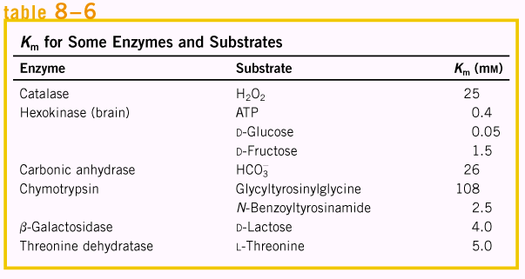 | 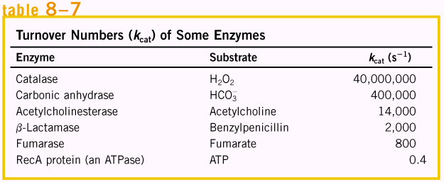

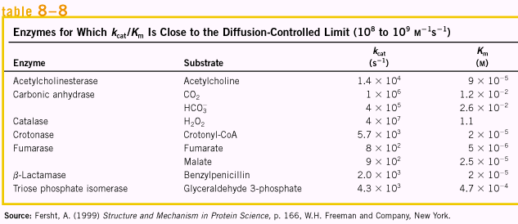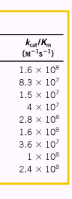
Many enzymes catalyze reactions with two or more substrates
Enzymatic reactions with two substrates usually involve transfer of an atom or a functional group from one substrate to the other. These reactions proceed by one of several different pathways, such as ternary complex and Ping-Pong or double displacement mechanism. Steady-state kinetics can often help distinguish among these possibilities.

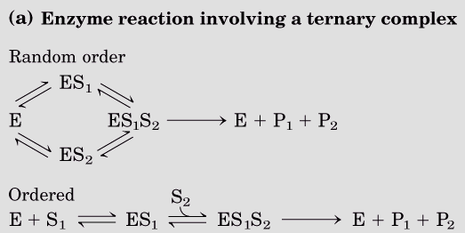 | 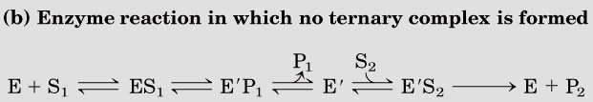  A Ping-Pong mechanism

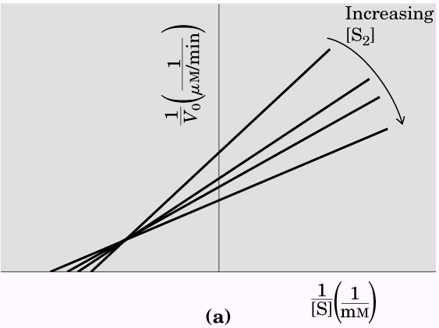 | 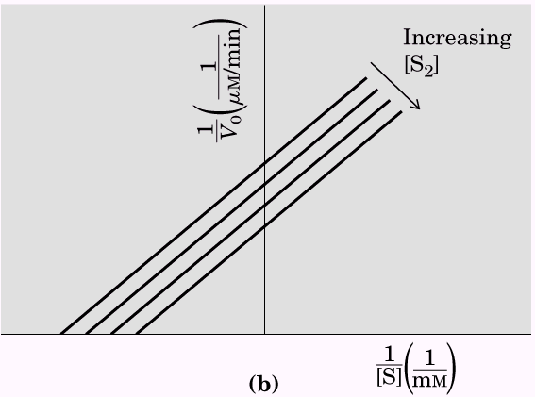
During the experiment, a parallel measurement of the Lineweaver-Burk plot are applied by variation the concentration of second substrate [S₂], so, several straight lines will be obtained. Intersecting lines indicate that a ternary complex is formed in the reaction, and parallel lines indicate a Ping-Pong or double-displacement pathway.

Enzymes are subject to inhibition
Enzyme inhibitors are molecular agents that interfere with catalysis, slowing or halting enzymatic reactions.

Reversible inhibition can be competitive, uncompetitive, or mixed
One common type of reversible inhibition is called competitive. A competitive inhibitor competes with the substrate for the active site of an enzyme. While the inhibitor (I) occupies the active site it prevents binding of the substrate to the enzyme. Competitive inhibitors are often compounds that resemble the substrate and combine with the enzyme to form an EI complex, but without leading to catalysis.
Competitive inhibition can be analyzed quantitatively by stead-state kinetics. In the presence of a competitive inhibitor, the Michaelis-Menten equation becomes
$V_{0}=\frac{V_{\text{max}}[S]}{{αK}_{m}+[S]}$ 8-22

Where $α=1+\frac{[I]}{K_{I}}$
And $K_{I}=\frac{[E][I]}{[\text{EI}]}$
The experimentally determined term αK_{m}, the K_{m} observed in the presence of the inhibitor, is often called the “apparent” K_{m}. When [S] far exceeds [I], the probability that an inhibitor molecule will bind to the enzyme is minimized, and the reaction exhibits a normal V_{max}. However, the [S] at which V₀ = ½V_{max}, the apparent K_{m}, will increase in the presence of inhibitor by the factor α. This effect on the apparent K_{m} combined with the absence of an effect on V_{max} is diagnostic of competitive inhibition and is readily revealed in a double-reciprocal plot.
An uncompetitive inhibitor binds at a site distinct from the substrate active site and, unlike a competitive inhibitor, binds only to the ES complex. In the presence of an uncompetitive inhibitor, the Michaelis-Menten equation is altered to:
$V_{0}=\frac{V_{\text{max}}[S]}{K_{m}+α'[S]}$ 8-23
Where $α'=1+\frac{[I]}{K'_{I}}$ and $K'_{I}=\frac{[\text{ES}][I]}{[\text{ESI}]}$

At high concentrations of substrate, V₀ approaches V_{max}/α’. Thus, an uncompetitive inhibitor lowers the measured V_{max}. The apparent K_{m} also decrease, because the [S] required to reach one-half V_{max} decreases by the factor α’.
A mixed inhibitor also binds at a site distinct from the substrate active site, but it will bind to either E or ES. The rate equation describing mixed inhibition is:
$V_{0}=\frac{V_{\text{max}}[S]}{{αK}_{m}+α'[S]}$ 8-24
A mixed inhibitor usually affects both K_{m} and V_{max}. The special case of α = α’, rarely encountered in practice, classically has been defined as noncompetitive inhibition. Noncompetitive inhibitor would affect the V_{max} but not the K_{m}.

The inhibition models are depicted in the following pictures.
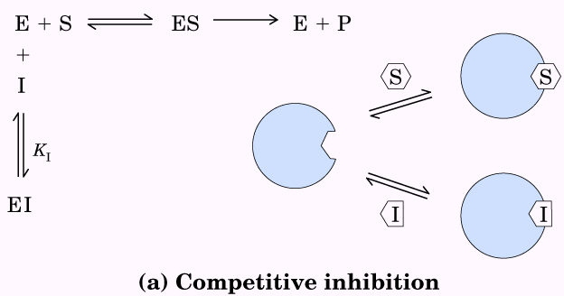 | 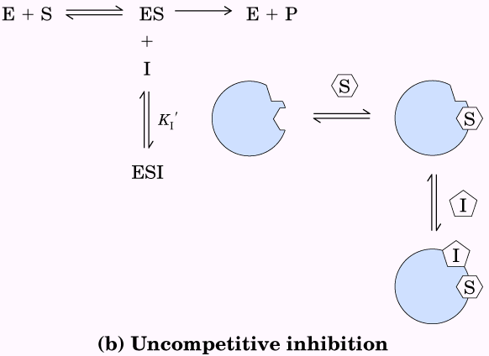 | 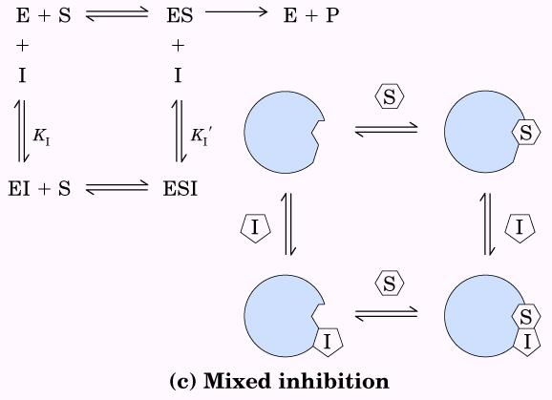

The experimental representation about the different inhibition is shown in the following Lineweaver-Burk plots.
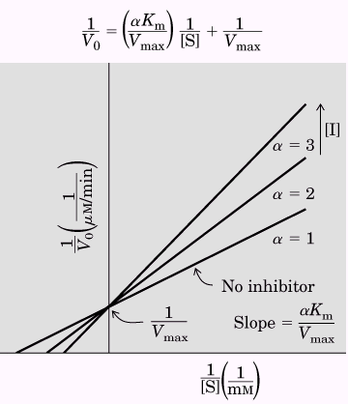  Competitive inhibition | 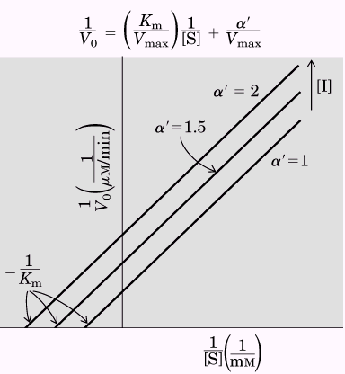  Uncompetitive inhibition | 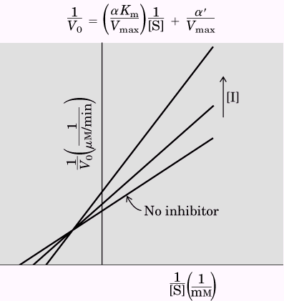  Mixed inhibition

Irreversible inhibition is an important tool in enzyme research and pharmacology
Irreversible inhibitors are those that combine with or destroy a functional group on an enzyme that is essential for the enzyme’s activity, or that form a particularly stable noncovalent association. Formation of a covalent link between an irreversible inhibitor and an enzyme is common. A special class of irreversible inhibitors is the suicide inactivators. These compounds are relatively unreactive until they bind to the active site of a specific enzyme. A suicide inactivator is designed to carry out the first few chemical steps of the normal enzyme reaction, but instead of being transformed into the normal product, the inactivator is converted to a very reactive compound that combines irreversibly with the enzyme. These compounds are also called mechanism-based inactivators, because they utilize the normal enzyme reaction mechanism to inactivate the enzyme.

Enzyme activity is affect by pH
Enzymes have an optimum pH (or pH range) at which their activity is maximal; at higher or lower pH, activity decreases. The pH range over which an enzyme undergoes changes in activity can provide a clue to what amino acid is involved.
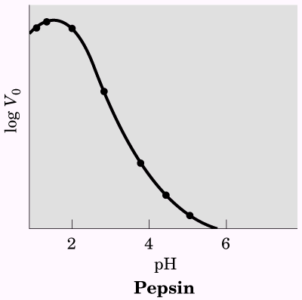  The pH-activity profiles for Pepsin | 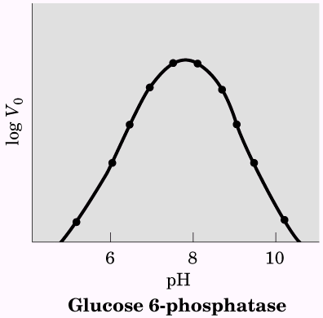  The pH-activity profiles for Glucose 6-phosphatase

Regulatory enzymes
In cellular metabolism, groups of enzymes work together in sequential pathways to carry out a given metabolic process. In each metabolic pathway, however, there is at least one enzyme that sets the rate of the overall sequence because it catalyzes the slowest or rate-limiting reaction. This enzyme is called regulatory enzyme. Furthermore, these regulatory enzymes exhibit increased or decreased catalytic activity in response to certain signals.
In most multienzyme systems, the first enzyme of the sequence is a regulatory enzyme. This is because catalyzing even the first few reactions of a pathway that leads to an unneeded product diverts energy and metabolites from more important processes. Therefore, an excellent place to regulate the pathway is at the point of commitment to that metabolic sequence. The other enzymes in the sequence are usually present at levels providing an excess of catalytic activity; they can generally promote their reactions as fast as their substrates are made available from preceding reactions.
There are two major classes of regulatory enzymes in metabolic pathways. Allosteric enzymes function through reversible, noncovalent binding of regulatory compounds called allosteric modulators, which are generally small metabolites or cofactors. Other enzymes are regulated by reversible covalent modification. Both classes of regulatory enzymes tend to be multisubunit proteins, and in some cases the regulatory site(s) and the active site are on separate subunits.
Moreover, some enzymes are stimulated or inhibited when separated regulatory proteins bind them. Others are activated when peptide segments are removed by proteolytic cleavage; unlike effector-mediated regulation, regulation by proteolytic cleavage is irreversible. For example in digestion, blood clotting, hormone action and vision.
To a degree, allosteric (noncovalent) regulation may permit fine-tuning of metabolic pathways that are required continuously but at different levels of activity as cellular conditions change. Regulation by covalent modification may be all or none---usually the case with proteolytic cleavage --- or it may allow for subtle changes in activity.

Allosteric enzymes undergo conformational change in response to modulator binding
The modulators for allosteric enzymes may be either inhibitory or stimulatory. An activator is often the substrate itself; regulatory enzymes for which substrate and modulator are identical are homotropic. The properties of allosteric enzymes are significantly different from those of simple nonregulatory enzymes. Some of the differences are structural. In addition to active sites, allosteric enzymes generally have one or more regulatory or allosteric sites for binding the modulator; each regulatory site is specific for its modulator. Enzymes with several modulators generally have different specific binding sites for each. In homotropic enzymes, the active site and regulatory site are the same.
Allosteric enzymes are generally larger and more complex than nonallosteric enzymes. Most have two or more polypeptide chains, or subunits.
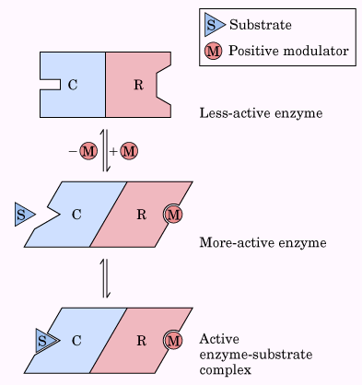
Subunit interactions in an allosteric enzyme, and interactions with inhibitors and activators

The regulatory step in many pathways is catalyzed by an allosteric enzyme
In some multienzyme systems, the regulatory enzyme is specifically inhibited by the end product of the pathway whenever the concentration of the end product exceeds the cell’s requirements. When the regulatory enzyme reaction is slowed, all subsequent enzymes operate at reduced rates as their substrates are depleted. The rate of production of the pathway’s end product is thereby brought into balance with the cell’s need. This type of regulation is called feedback inhibition.

The kinetic properties of allosteric enzymes diverge from Michaelis-Menten behavior
Allosteric enzymes show relationships between V₀ and [S] that differ from Michaelis-Menten kinetics. They do exhibit saturation with the substrate when [S] is sufficiently high, but for some allosteric enzymes, when V₀ is plotted against [S], a sigmoid saturation curve results, rather than the hyperbolic curve typical of nonregulatory enzymes. Under this condition, [S]_{0.5} or _{K0.5} is often used to represent the substrate concentration giving half-maximal velocity of the reaction catalyzed by an allosteric enzyme.
Sigmoid kinetic behavior generally reflects cooperative interactions between multiple protein subunits. Homotropic allosteric enzymes generally have multiple subunits. One characteristic of sigmoid kinetics is that small changes in the concentration of a modulator can be associated with large changes in activity.
For heterotropic allosteric enzymes, with a modulator that is a metabolite other than the substrate itself, it is difficult to generalize about the shape of the substrate-saturation curve. These kind of kinetic data are depicted as follows.

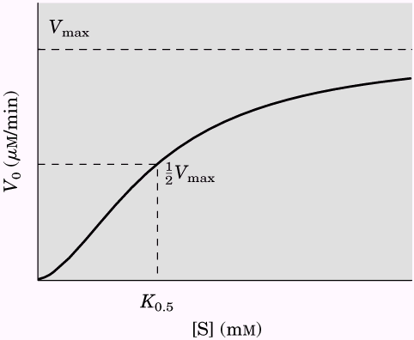  Homotropic allosteric enzyme | 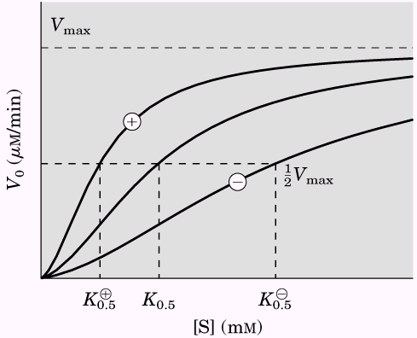  Heterotropic allosteric enzyme | 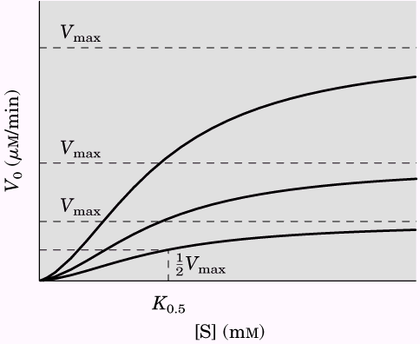  Heterotropic allosteric enzyme

Some regulatory enzymes undergo reversible covalent modification
In another important class of regulatory enzymes, activity is modulated by covalent modification of the enzyme molecule. Modifying groups include phosphoryl, adenylyl, uridylyl, adenosine diphosphate ribosyl, and methyl groups. These groups are generally covalently linked to and removed from the regulatory enzyme by separate enzymes.
Phosphorylations make up the vast majority of known regulatory modifications; one-third to one-half of all proteins in a eukaryotic cell are phosphorylated.

Phosphoryl groups affect the structure and catalytic activity of proteins
The attachment of phosphoryl groups to specific amino acid residues of a protein is catalyzed by protein kinases; removal of phosphoryl groups is catalyzed by protein phosphatases. The addition of a phosphoryl group to a Ser, Thr, or Tyr residue introduces a bulky, charged group into a region that was only moderately polar. The oxygens of a phosphoryl group are capable of hydrogen bonding with one or several groups in a protein, commonly the amide groups of the peptide backbone at the start of an α helix or the changed guanidinium group of the Arg side chain. The double negative charge on a phosphorylated side chain can also repel neighboring negatively charged (Asp or Glu) residues.
Phosphorylation of an enzyme can affect catalysis in another way: by altering substrate-binding affinity. On the other hand, interactions between subunits of multimeric structural proteins can also be altered by phosphorylation at the site of interaction.

Multiple Phosphorylations allow exquisite regulatory control
The Ser, Thr, or Tyr residues that are phosphorylated in regulated proteins occur within common structural motifs, called consensus sequences that are recognized by specific protein kinases. Some kinases are basophilic, preferring to phosphorylate a residue having basic neighbors, other have different substrate preferences, such as for a residue near a proline. Primary sequence is not the only important factor in determining whether a given residue will be phosphorylated. One factor influencing the substrate specificity of certain protein kinases is the proximity of other phosphorylated residues.
To serve as an effective regulatory mechanism, phosphorylation must be reversible. In general, phosphoryl groups are added and removed by different enzymes, and the processes can therefore be separately regulated.

Some types of regulation require proteolytic cleavage of an enzyme precursor
For some enzymes, an inactive precursor called a zymogen is cleaved to form the active enzyme. Many proteolytic enzymes (proteases) of the stomach and pancreas are regulated in this way. Specific cleavage causes conformational changes that expose the enzyme active site. Because this type of activation is irreversible, other mechanisms are needed to inactivate these enzymes. Inhibitor proteins that bind very tightly to the enzyme active site inactivate proteases.
Proteases are not the only proteins activated by proteolysis. In other cases, however, the precursors are called not zymogens but, more generally, proproteins or proenzymes, as appropriate.

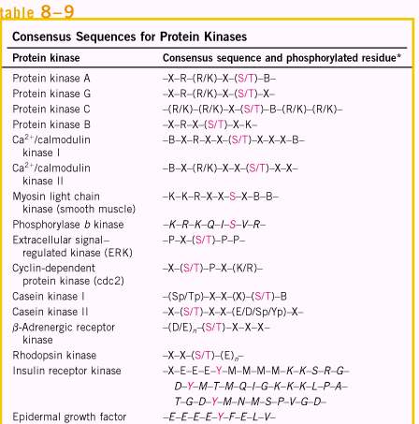

Some regulatory enzymes use multiple regulatory mechanisms

