Water

Hydrogen bonding gives water its unusual properties

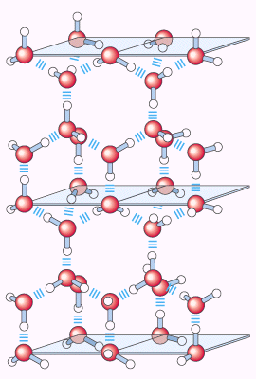
Fig. 1 The crystal structure of water in ice

In water, the electrostatic attraction between the oxygen atom of one water molecule and the hydrogen of another water molecule, is called hydrogen bond. In ice, each water molecule form four hydrogen bonds with its neighboring water molecules, however, in liquid water, some crystal lattice have been broken, and water molecules move around, so a water molecule forms averaged 3.4 hydrogen bonds with its neighboring water molecules. The hydrogen bonds between water molecules and the crystal structure of solid water is shown in Fig. 1.

Table 1. Comparison of m.p., b.p. and heat of vaporization of water with other molecules
molecule | Melting point (m.p.) | Boiling point(b.p.) | Heat of vaporization
Water | 0 | 100 | 2,260
Ethanol | -117 | 78 | 854
Acetone | -95 | 56 | 523
Butane | -135 | -0.5 | 381
Butanol | -90 | 117 | 590
* m.p. and b.p. in unit of °C, heat of vaporization in unit of J/g

Normally, for organic compound, the higher the molecule weight, the higher the melting point, and boiling point, however, in the presence of hydrogen bond, the case might be different, for example, ethanol has higher b.p. and m.p. than butane.

Bond dissociation energy is the energy required to break a bond, the bond dissociation energy of hydrogen bond is only 20 kJ/mol, thus is weak comparing to the single bond of C-C, which is 348 kJ/mol.

Hydrogen bond in liquid water is under dynamic state, because the water molecules move very fast, once it form hydrogen bond with its neighboring molecules, the hydrogen bond will break after that particular molecule move to other place, and form another hydrogen bond with its neighboring molecules again. The lifetime of each hydrogen bond is 1×10⁻⁹s.

Vaporization heat is the energy required for a molecule to change from its liquid state to vaporous state. H₂O (l) ----→ H₂O (g) ΔH = + 44.0 kJ/mol. This is the reason water has its high boiling point.

Fig. 2 Phase diagram during the variation of pressure and temperature

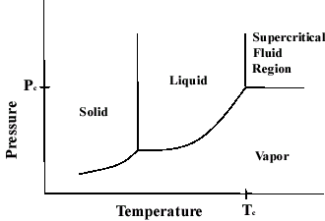

When temperature reaches 374.0 °C and the pressure is kept at 217.8 atm, water will form supercritical fluid state (homogeneous state), where the density of water is around 750 g /L.

Supercritical water has many applications already.

Water forms hydrogen bond with polar solutes
Common hydrogen bond pairs in biomolecules

Hydrogen bond does not exist in water molecule only, other molecules with polar functional group such as hydroxyl, carboxyl acid, and amino group can form hydrogen bonds within these molecules also. Because of the hydrogen bond, in nucleic acid, thymine can only form pairs with adenine, and guanine can only form pairs with cytosine, under this circumstance, the strongest hydrogen bond can be form, and the genetic code is secured by this kind of complementary pairs.

Water interacts electrostatically with charged solutes

Fig. 3 Water dissolves many crystalline salts by hydrating their component ions.
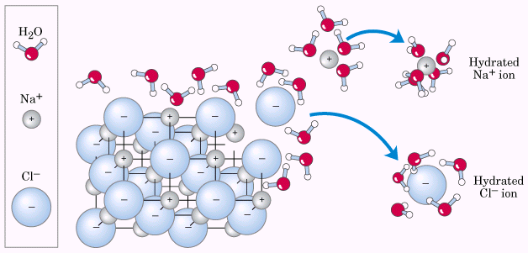
Term: Hydrophilic
Hydrophobic

For the molecules with positive and negative charged pairs, can dissolved in water readily, as water has much higher dielectric constant (ε, 78.5) than many other solvents. For example, benzene (4.6), THF (20.0). The electrostatic interaction is determined by three factors, as shown in equation.
When charged molecules dissolve in water, the molecules will be solvated by water, and the separated positive charge and negative charge part of the molecules will be stabilized by many surrounding water molecules. During the process of solvation, the entropy is increased.

Nonpolar compounds dissolve in water poorly

For nonpolar gas, such as oxygen, nitrogen, carbon dioxide, dissolve very poorly in water.
For other nonpolar molecules, such as benzene, hexane, cannot dissolve in water either, and will form two phases.

Any molecules dissolve into water, will disturb the spatial orientation of water, and break down some of the hydrogen bond between water molecules. For charged or polar molecules, when they dissolve into water, although part of hydrogen bond is broken, the charged or polar molecule can form hydrogen bond with water molecules, or can form electrostatic interaction, and these new formed interaction will compensate the broken hydrogen bond present originally in water. However, for nonpolar molecules, they are hydrophobic. When they meet with water molecules, the water molecules are forced to form a cage around these nonpolar molecules, and the partially lost hydrogen bond cannot be compensated, in addition, entropy is reduced also, because water molecules form ordered constitution.

When a molecule contains both hydrophilic (polar) part and hydrophobic (nonpolar) part, this kind of molecules has intermediate solubility in water. When this kind of molecules is called amphipathic (amphiphilic) compounds.
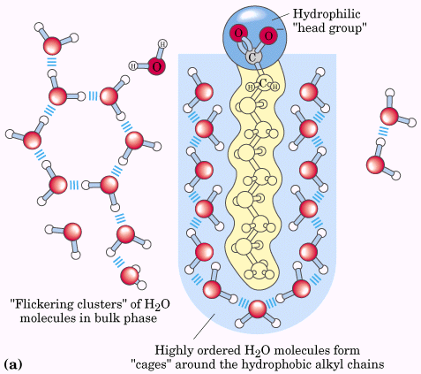
Fig 4. Long chain fatty acid is surrounded by a layer of water molecules, because of lower solubility of alkyl chain in water

Amphipathic molecules can form micelles in two kind of models
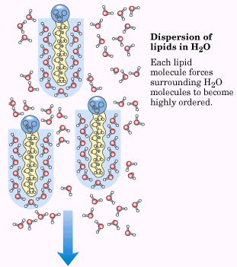
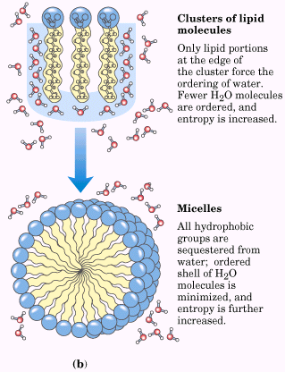
Fig. 5 Amphipathic molecules form micelles by clustering together

Fig. 6 Amphipathic molecules can form micelles in bilayers, like cellular plasma membrane

Forming micelles has many applications in our daily life. For example, soap is a kind of molecules (potassium or sodium salt of carboxylic acids, first generation), which has polar part (carboxylic acid) and nonpolar part (hydrocarbon chain up to 17 carbon atoms). Soap is used to clean many oil stains on clothes and so on.
Paint

Weak interactions are crucial to macromolecular structures and functions

All the biomolecules are composed of monomeric subunits, with many functional groups such as amino, carbonyl, hydroxyl, ester, phosphate and so on. The four kinds of weak interactions including hydrogen bond, ionic interaction, hydrophobic and lipophilic interaction (HLI), and van der Waals interactions all exist within these molecules. Although these interactions are very weak, comparing to covalent bond interaction, these weak interaction collectively will control the interaction between the biomolecules. And it is this kind of weak interactions between biomolecules, that the interactions between the biomolecules are highly specific, selective and reversible. For example, the interactions exist in the antibody-antigen, enzyme-substrate and ligand-receptor couples. The conformation of biomolecules in aqueous solution will take the specific conformation where all the weak-bonding possibilities can be maximized.

After binding of enzyme with ligand, both enzyme and ligand will release some water molecules that associate with them originally, and the entropy is increased.

Solutes affect the colligative properties of aqueous solutions

Colligative property describes the property of solution of which the change is depending on the number of particles (as molecules) and not on the nature of the particles, this kind of property includes vapor pressure, boiling point, melting point (freezing point), and osmotic pressure.

Dissolved solutes alter the colligative properties of aqueous solution by lowering the effective concentration of water. (1.86 °C for m.p., 0.543 °C for b.p. at 1M solution).

Osmotic pressure is determined by Π = icRT, where ic is the osmolarity of the solution. When more than one solute dissolves in the solution, the osmotic pressure is the sum of all the contribution of each solutes.

Π = RT (i₁c₁ + i₂c₂ + …. + i_{n}c_{n})

Many membranes allow all or none of the constituents of a solution to pass through; only a few allow a selective flow. In classic demonstration of osmosis, a vertical tube containing a solution of sugar, with its lower end closed off by a semipermeable membrane, is placed in a container of water. As the water passes through the membrane into the tube, the level of sugar solution in the tube rises visibly. A semipermeable membrane that may be used for such a demonstration is the membrane found just inside the shell of an egg, that is, the film that keeps the white of the egg from direct contact with the shell.

Three mechanisms for cell to prevent the osmotic lysis:

Ionization of water, weak acids and weak bases

Pure water is slightly ionized.
How do we know that water is ionized? We know for sure that a salt like NaCl dissolves in water, it is ionized, a weak acid, like acetic acid, when it dissolve into water, it is ionized. When water is electrolysized, hydrogen will be released at cathode, and oxygen will be released from anode.

We can think that water is a weak acid, it can be ionized to give proton and its conjugate base, hydroxide anion. The proton is hydrated by other water molecules to stabilize the proton cation, in fact, hydroxide is also hydrated by other water molecules.

proton hopping

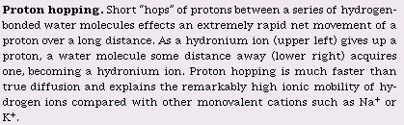

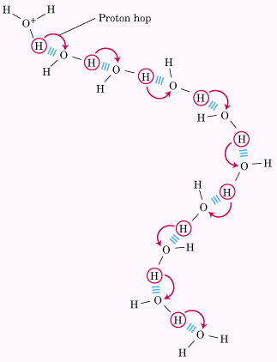
Fig. 7 the proton hopping

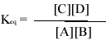

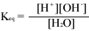
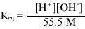

(55.5 M)(K_{eq}) = [H⁺][OH⁻] = K_{w} = (55.5 M)(1.8×10⁻¹⁶ M) = 1.0 ×10⁻¹⁴ M²

when water is neutral, where [H⁺] = [OH⁻], so, [H⁺] = √Kw =√ 1×10⁻¹⁴ M²

[H⁺] = [OH⁻] = 10⁻⁷M

The pH scale designates the H⁺ and OH⁻ concentrations

The term pH is defined by the expression

Note: the ion product of water will vary with temperature, at 25°C, when water is neutral, pH = 7. When temperature increases to around 100 °C, K_{w} = 10⁻¹² M², at that temperature, when water is neutral, pH = 6.

Weak acids and bases have characteristic dissociation constants
The weak acis and bases are those acids and bases that are ionized partially in dilute aqueous solution. Acids are defined as proton donors, and bases are defined as proton acceptors. Proton donor and its corresponding proton acceptor make up a conjugate acid-base pair.

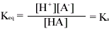

pK_{a} = - log K_{a}

Fig. 8 The titration curve of acetic acid

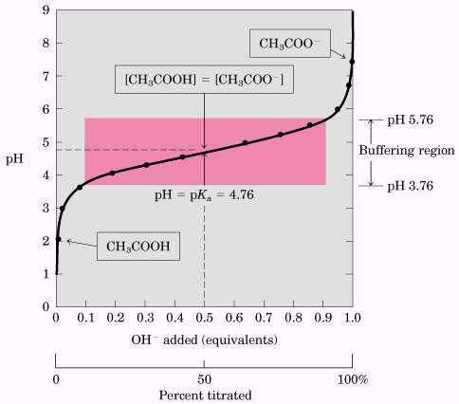

Fig. 9 Comparison of the titration curves of three weak acids, acetic acid, H₂PO₄⁻ and NH₄⁺

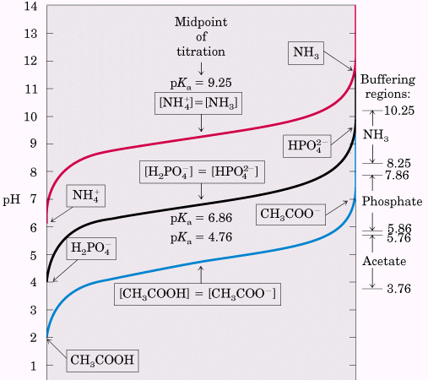

Fig. 10 The pH optima of some enzymes

