Biosignaling

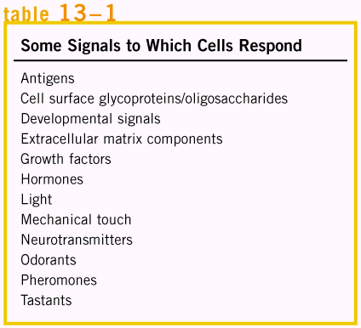 | The ability of cells to receive and act on signals from beyond the plasma membrane is fundamental to life. The signals in animals may be autocrine (acting on the same cell that produces them), paracrine (acting on a near neighbor), or endocrine (carried in the bloodstream from the producer cell to a distant target cell). In all three cases, the signal is detected by a specific receptor and is converted to a cellular response.  Although the number of biological signals is legion (left table), as is the variety of biological responses to these signals, organisms use just a few evolutionarily conserved mechanisms to detect extracellular signals and transduce them into intracellular changes. Often, the end result of a signaling pathway is the phosphorylation of a few specific target cell proteins, which changes their activities and thus the activities of the cell.

Molecular mechanisms of signal transduction

Signal transductions are remarkably specific and exquisitely sensitive. Specificity is achieved by precise molecular complementarity between the signal and receptor molecules, mediated by the same kinds of weak (noncovalent) forces that occur in enzyme-substrate and antigen-antibody interactions. | 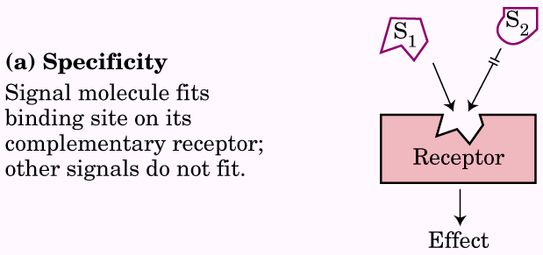 | 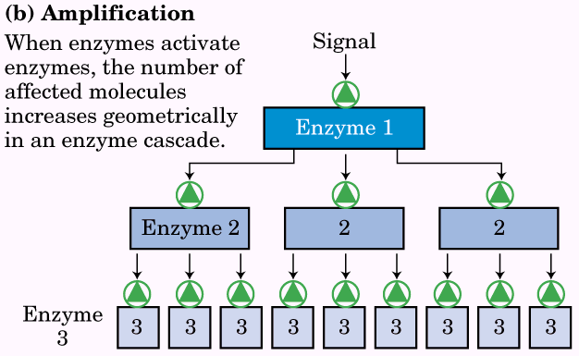
Three factors account for the extraordinary sensitivity of signal transducers: the high affinity of receptors for signal molecules, cooperativity in the ligand-receptor interaction, and amplification of the signal by enzyme cascades. The affinity between signal (ligand) and receptor can be expressed as the dissociation constant K_{d}, often | 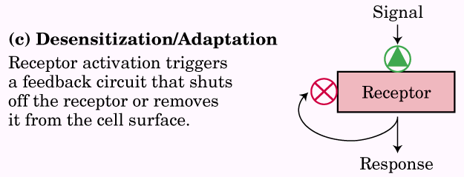 | 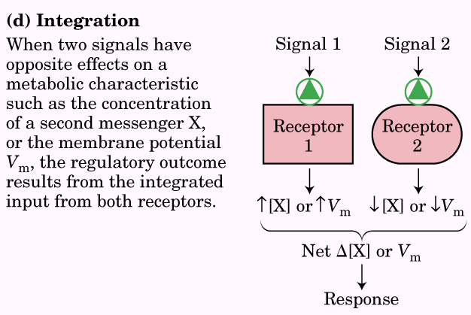
10⁻¹⁰M or smaller, meaning that the receptor can detect picomolar concentrations of a signal molecule. Receptor-ligand interactions can be quantified by Scatchard analysis, which, in the best cases, yields a quantitative measure of affinity (K_{d}) and the number of ligand-binding sites in a receptor sample. Cooperativity in receptor-ligand interactions results in large changes in receptor activation with small changes in ligand concentration. Amplification by enzyme cascades results when an enzyme associated with a signal receptor is activated and, in turn, catalyzes the activation of many molecules of a second enzyme, each of which activates many molecules of a third enzyme, and so on. Amplifications of several orders of magnitude can be produced in milliseconds by such cascades.
The sensitivity of receptor systems is subject to modification. When a signal is present continuously, desensitization of the receptor system results; when the stimulus falls below a certain threshold, the system again becomes sensitive. A final noteworthy feature of signal-transducing systems is integration, the ability of the system to receive multiple signals and produce a unified response appropriate to the needs of the cell or organism.

Scatchard analysis quantifies the receptor-ligand interaction
Receptor-ligand binding is described by the equation.

this binding, like that of an enzyme to its substrate, is dependent on the concentrations of the interacting components and can be described by an equilibrium constant:
$$K=\frac{[\text{RL}]}{[R][L]}=\frac{k_{+1}}{k_{−1}}=\frac{1}{K_{d}}$$
where K_{a} is the association constant and K_{d} is the dissociation constant.
As in the case of enzyme-substrate binding, receptor-ligand binding is saturable. A rough measure of the receptor-ligand affinity is given by the concentration of ligand needed to given half-saturation of the receptor. Scatchard analysis of receptor-ligand binding allows an estimation of both the dissociation constant K_{d} and the number of receptor-binding sites in a given preparation. Let B_{max} =[R] + [RL], where B_{max} is the total number of possible binding sites, [R] is the number of unoccupied sites, [RL] is the number of occupied or ligand-bound sites.
$$K_{a}=\frac{[\text{RL}]}{[L](B_{\text{max}}−[\text{RL}])}$$
$$\frac{[\text{Bound}]}{[\text{Free}]}=\frac{[\text{RL}]}{[L]}=K_{a}(B_{\text{max}}−[\text{RL}])=\frac{1}{K_{d}}(B_{\text{max}}−[\text{RL}])$$
Scatchard analysis is reliable for the simplest cases, when the receptor is an allosteric protein, the plots show deviation from linearity.
The trigger for each system is different, but the general features of signal transduction are common to all: a signal interacts with a receptor; the activated receptor interacts with cellular machinery, producing a second signal or a change in the activity of a cellular protein; the metabolic activity of the target cell undergoes a change; and finally, the transduction event is terminated and the cell returns to its prestimulus state.
The simplest signal transducers are ion channels of the plasma membrane that open and close (hence the term “gating”) in response to the binding of chemical ligands or changes in transmembrane potential.

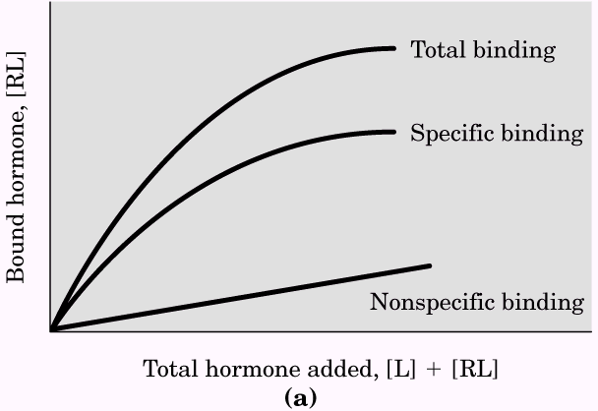 | 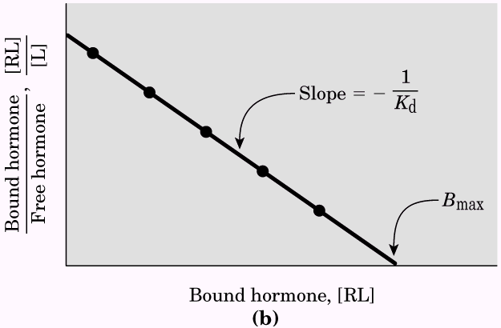
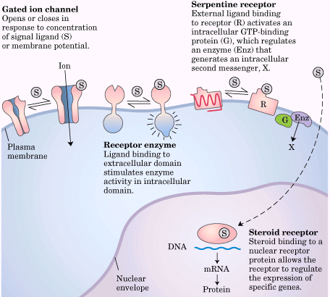 | 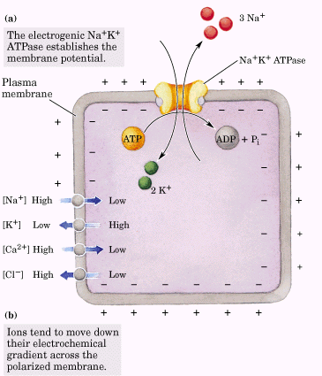

Gated ion channels
Ion channels underlie electrical signaling in excitable cells
The excitablitiy of sensory cells, neurons, and myocytes depends on ion channels, signal transducers that provide a regulated path for the movement of inorganic ions such as Na⁺, K⁺, Ca₂⁺, and Cl⁻ across the plasma membrane in response to various stimuli. By convention, V_{m} is negative when the inside of the cell is negative relative to the outside. For a typical animal cell, Vm = -60 to –70 mV.
Because ion channels generally allow passage of either anions or cations but not both, ion flux through a channel causes a redistribution of charge on the two sides of the membrane, changing Vm.
A given ionic species continues to flow through a channel only as long as the combination of concentration gradient and electrical potential provides a driving force, according to equation.
The equilibrium potential is different for each ionic species because the concentration gradients differ for each ion.
The number of ions that must flow to change the membrane potential significantly is negligible relative to the large concentrations of Na⁺, K⁺, and Cl⁻ in cells and extracellular fluid, so the ion fluxes that occur during signaling in excitable cells have essentially no effect on the concentrations of those ions. However, because the intracellular concentration of Ca²⁺ is generally very low (~10⁻⁷M), inward flow of Ca²⁺ can significantly alter the cytosolic [Ca²⁺].
The membrane potential of a cell at a given time is the result of the types and numbers of ion channels open at that instant. In most cells at rest, more K⁺ channels than Na⁺, Cl⁻, or Ca²⁺ channels are open and thus the resting potential is cloer to the E for K⁺ (-98 mV) than that for any other ions.
The nicotinic acetylcholine receptor is a ligand-gated ion channel
One of the best-understood examples of a ligand-gated receptor channel is the nicotinic acetylcholine receptor. The receptor channel opens in response to the neurotransmitter acetylcholine (and to nicotine, hence the name). This receptor is found in the postsynaptic membrane of neurons at certain synapses and in muscle fibers (myocytes) at neuromuscular junctions.
Acetylcholine released by an excited neuron diffuses a few micrometers across the synaptic cleft or neuromuscular junction to the postsynaptic neuron or myocytes, where it interacts with the acetylcholine receptor and triggers electrical excitation (depolarization) of the receiving cell. The acetylcholine receptor is an allosteric protein with two high-affinity binding sites for acetylcholine, about 3.0 nm from the ion gate, on the two α subunits. The binding of acetylcholine causes a change from the closed to the open conformation. The process is positively cooperative: binding of acetylcholine to the first site increases the acetylcholine-binding affinity of the second site. When the presynaptic cell releases a brief pulse of acetylcholine, both sites on the postsynaptic cell receptor are occupied briefly, and the channel opens. Either Na⁺ or Ca²⁺ can now pass, and the inward flux of these ions depolarizes the plasma membrane, initiating subsequent events that vary with the type of tissue.

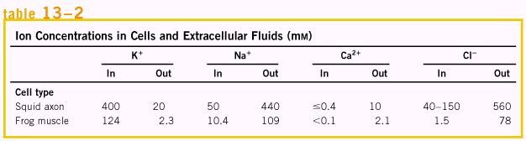

voltage-gated ion channels produce neuronal action potentials
signaling in the nervous system is accomplished by networks of neurons, specialized cells that carry an electrical impulse (action potential) from one end of the cell (the cell body) through an elongated cytoplasmic extension (the axon). The electrical signal triggers release of neurotransmitter molecules at the synapse, carrying the signal to the next cell in the circuit. Three types of voltage-gated ion channels are essential to this signaling mechanism. Along the entire length of the axon are voltage-gated Na⁺ channels, which are closed when the membrane is at rest (Vm = - 60 mV) but open briefly when the membrane is depolarized locally in response to acetylcholine (or some other neurotransmitter). The depolarization induced by the opening of Na⁺ channels causes voltage-gated K⁺ channels to open and the resulting efflux of K⁺ repolarizes the membrane locally. A brief pulse of depolarization traverses the axon as local depolarization triggers the brief opening of neighboring Na⁺ channels, then K⁺ channels.
At the distal tip of the axon are voltage-gated Ca²⁺ channels. When the wave of depolarization reaches them, these channels open, and Ca²⁺ enters from the extracellular space. Acting as an intracellular second messenger, Ca²⁺ then triggers release of acetylcholine by exocytosis into the synaptic cleft. Acetylcholine diffuses to the postsynaptic cell(another neuron or a myocytes), where it binds to acetylcholine receptors and triggers depolarization. Thus the message is passed to the next cell in the circuit.

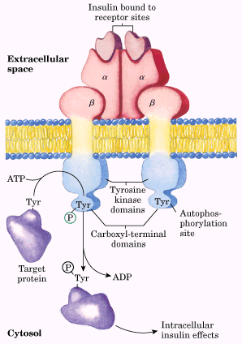 | 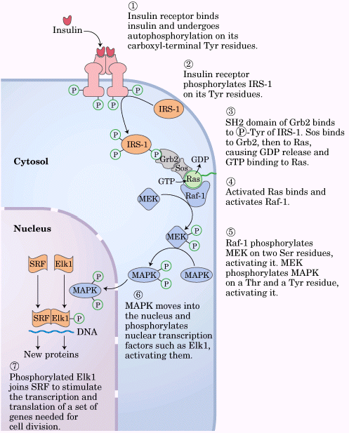
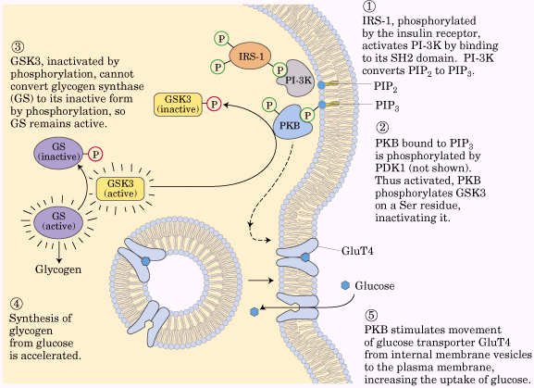 | 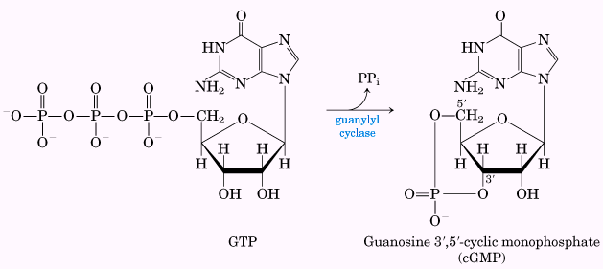

Neurons have receptor channels that respond to a variety of neurotransmitters
Serotonin and glutamate trigger the opening of cation (K⁺, Na⁺, Ca²⁺) channels, whereas glycine opens Cl⁻ specific channels. Cation and anion channels are distinguished by subtle differences in the amino acid residues that line the hydrophilic channel. Cation channels have negatively charged Glu and Asp side chains at crucial positions. When a few of these acidic residues are experimentally replaced with basic residues, the cation channel is converted to an anion channel.

Receptor enzymes
A fundamentally different mechanism of signal transduction is carried out by the receptor enzymes. These proteins have a ligand-binding domain on the extracellular surface of the plasma membrane and an enzyme active site on the cytosolic side, with the two domains connected by a single transmembrane segment. Commonly, the receptor enzyme is a protein kinase that phosphorylation Tyr residues in specific target proteins.
The insulin receptor is a tyrosine-specific protein kinase
Insulin regulates both metabolism and gene expression: the insulin signal passes from the plasma membrane receptor to insulin-sensitive metabolic enzymes and to the nucleus, where it stimulates the transcription of specific genes.
Guanylyl cyclase is a receptor enzyme that generates the second messenger cGMP
Guanylyl cyclase is another type of receptor enzyme. When activated, it produces guanosine 3’,5’-cyclic monophosphate (cyclic GMP or cGMP) from GTP:
Cyclic GMP is a second messenger that carries different messages in different tissues. In the kidney and intestine it triggers changes in ion transport and water retention; in cardiac (smooth) muscle it signals relexation; in the brain it may be involved in both development and adult brain function.
Guanylyl cyclase in the kidney is activated by the hormone atrial natriuretic factor (ANF), which is released by cells in the atrium of the heart when it is stretched by increased blood volume.
A distinctly different type of guanylyl cyclase is a cytosolic protein with a tightly associated heme group. This enzyme is activated by nitric oxide (NO). nitric oxide is produced from arginine by Ca²⁺ dependent NO synthase, present in many mammalian tissues, and diffuses from its cell of origin into nearby cells.
Most of the actions of cGMP are believed to be mediated by cGMP-dependent protei nkinase, also called protein kinase G or PKG, which phosphorylates Ser and Thr residues in target proteins when activated by cGMP.
Cyclic GMP has a second mode of action in the vertebrate eye: it causes ion-specific channels to open in the retinal rod and cone cells.

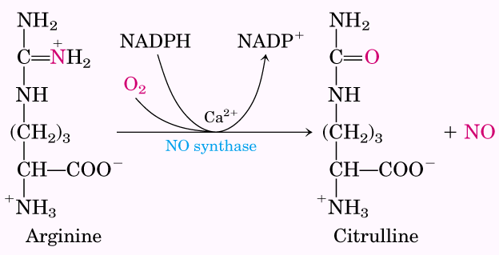 | 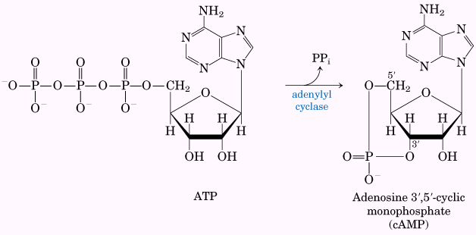
G protein-coupled receptors and second messengers
A third mechanism of signal transduction, distinct from gated ion channels and receptor enzymes, is defined by three essential components: a plasma membrane receptor with seven transmembrane segments, an enzyme in the plasma membrane that generates an intracellular second messenger, and a GTP-binding protein that dissociates from the occupied receptor and binds to the enzyme, activating it.
The β-adrenergic receptor system acts through the second messenger cAMP
Epinephrine action begins when the hormone binds to a protein receptor in the plasma membrane of a hormone-sensitive cell. Adrenergic receptors (“adrenergic” reflects the alternative name for epinephrine, adrenaline) are of four general types, defined by subtle differences in their affinities and responses to a group of agonists and antagonists. Agonists are structural analogs that bind to a receptor and mimic the effects of its natural lignad; antagonists are analogs that bind without triggering the normal effect and thereby block the effects of agonists.
The β-adrenergic receptor is an integral protein with seven hydrophobic regions of 20 to 28 residues that “snake” back and forth seven times across the plasma membrane. This protein is a member of a very large family of receptors, all with seven transmembrane helices, that are commonly called serpentine receptors.
Adenylyl cylcase is an integral protein of the plasma membrane with its active site on the cytosolic face. It catalyzes the synthesis of camp from ATP. The association of active Gsa with adenylyl cyclase stimulates the enzyme to catalyze camp synthesis, raising the cytosolic [camp]. This stimulation by Gsa is self-limiting; Gsa is a GTPase that turns itself off by converting its bound GTP to GDP.
cAMP-dependent protein kinase, also called protein kinase A or PKA, which is allosterically activated by cAMP, catalyzes the phosphorylation of inactive phosphorylase b kinase to yield the active form.
The β-adrenergic receptor is desensitized by phosphorylation
Signal-transducing systems undergo desensitization when the signal persists. Desensitization of the β-adrenergic receptor is mediated by a protein kinase that phosphorylates the receptor on the (intracellular) domain that normally interacts with Gs. When the receptor is occupied by epinephrine, b-adrenergic receptor kinase (bark) phosphrylates Ser residues near the carboxyl terminus of the receptor.

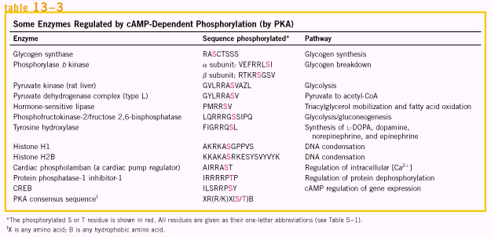 | 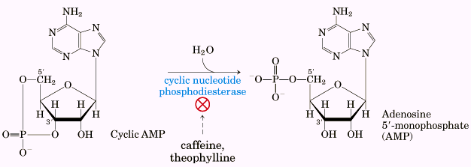

Cyclic AMP acts as a second messenger for a number of regulatory molecules
Epinephrine is only one of many hormones, growth factors, and other regulatory molecules that act by changing the intracellular [camp] and thus the activity of PKA. Some hormones act by inhibiting adenylyl cyclase, lowering camp levels, and suppressing protein phosphorylation.
Two second messengers are derived from phosphatidylinositols
A second class of serpentine receptors are coupled through a G protein to a plasma membrane phsopholipase C that is specific for the plasma membrane lipid phosphatidylinositol 4,5-bisphosphate. This hormone-sensitive enzyme catalyzes the formation of two potent second messengers: diacylglycerol and inositol 1,4,5-triphosphate, or IP3. the action of a group of compounds known as tumor promoters is attributable to their effects on PKC.

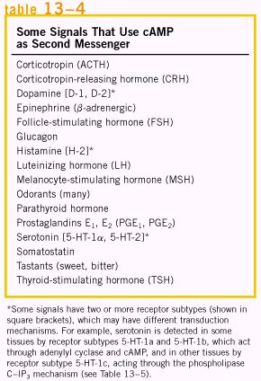 | 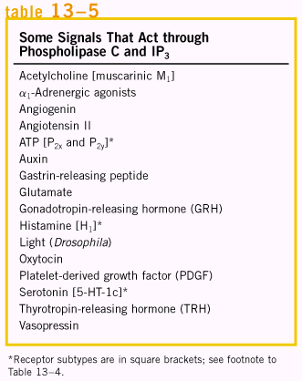

Calcium is a second messenger in many signal transductions
In many cells that respond to extracellular signals, Ca²⁺ serves as a second messenger that triggers intracellular responses, such as exocytosis in neurons and endocrine cells, contraction in muscle, or cytoskeletal rearrangement during amoeboid movement. Very commonly, [Ca²⁺] does not simply rise and then decay, but rather oscillates with a period of a few seconds, even when the extracellular concentration of hormone remains constant. The mechanism underlying [Ca²⁺] oscillations presumably involves feedback regulation by Ca²⁺ of either the phospholipase that generates IP3 or the ion channel that regulates Ca²⁺ release from the ER, or both. Changes in intracellular [Ca²⁺] are detected by calcium-binding proteins that regulate a variety of Ca²⁺-dependent enzymes. Calmodulin (CaM; Mr 17,000) is an acidic protein with four high-affinity Ca²⁺-binding sites. Calmodulin is an integral subunit of Ca²⁺/calmodulin-dependent protein kinase (CaM kinase). When intracellular [Ca²⁺] increases in response to some stimulus, calmodulin binds Ca²⁺, undergoes a change in conformation, and activates CaM kinase. The kinase then phosphorylates a number of target enzymes, regulating their activities.

Sensory tranduction in vision, olfaction, and gustation
An initial sensory signal is amplified greatly by mechanisms that involve gated ion channels and intracellular second messengers; the system adapts to continued stimulation by changing its sensitivity to the stimulus (desensitization); and sensory input from several receptors is integrated before the final signal goes to the brain.
Light hyperpolarizes rod and cone cells of the vertebrate eye
In the vertebrate eye, a beam of light entering through the pupil is focused on a highly organized collection of light-sensitive neurons. The light-sensing cells are of two types: rods (about 10⁹ per retina), which sense low levels of light but cannot discriminate colors, and cones (about 3 ×10⁶ per retina), which are less sensitive but can discriminate colors. Both cell types are long, narrow, specialized sensory neurons with two distinct cellular compartments: an outer segment, which contains dozens of membranous disks loaded with the membrane protein rhodopsin, and an inner segment containing the nucleus and many mitochondria, which produce the ATP essential to phototransduction.
Like other neurons, rods and cones have a transmembrane electrical potential (Vm), produced by the electrogenic pumping of the Na⁺K⁺ ATPase in the plasma membrane of the inner segment. In the dark, rod cells contain enough cGMP to keep this channel open. The membrane potential is therefore determined by the net difference between the Na⁺ and K⁺ pumped by the inner segment. The essence of signaling in the retinal rod or cone cell is a light-induced decrease in the concentration of cGMP, which causes the cGMP-gated ion channel to close.

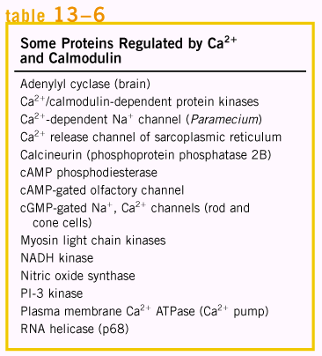 | 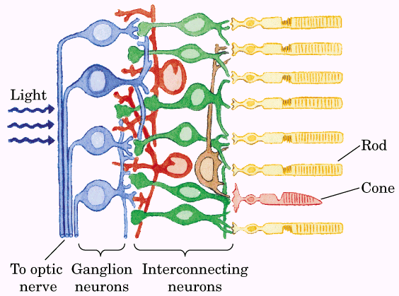

Light triggers conformational changes in the receptor rhodopsin
Visual transduction begins when light falls on rhodopsin, many thousands of molecules of which are present in each of the disks of the outer segment. Rhodopsin (Mr 40,000) is an integral protein with seven membrane-spanning α helices, the characteristic serpentine architecture. The light-absorbing pigment (chromophore) 11-cis-retinal is covalently attached to opsin, the protein component of rhodopsin, through a Schiff base to a Lys residue. When a photon is absorbed by the retinal component of rhodopsin, the energy causes a photochemical change; 11-cis-retinal is converted to all-trans-retinal. This change in the structure of the chromophore causes conformational changes in the rhodopsin molecule-the first stage in visual transduction.
Excited rhodopsin acts through the G protein transducin to reduce the cGMP concentration
In its excited conformation, rhodopsin is able to interact with a second protein, transducin, which hovers nearby on the cytosolic face of the disk membrane. Transducin (T) belongs to the same family of trimeric GTP-binding proteins as Gs and Gi. Although specialized for visual transduction, transducin shares many functional features with Gs and Gi. It can bind either GDP or GTP. In the dark, GDP is bound, all three subunits of the protein (Ta, Tb, and Tg) remain together, and no signal is sent. When rhodopsin is excited by light, it interacts with transducin, catalyzing the replacement of bound GDP by GTP from the cytosol.transducin then dissociates into Ta and Tbg, and the GTP-bound Ta carries the signal from the excited receptor to the next element in the transduction pathway, cGMP phosphodiesterase (PDE), an enzyme that converts cGMP to 5’-GMP. The cGMP-specific PDE is unique to the visual cells of the retina.
PDE is an integral protein with its active site on the sytosolic side of the disk membrane. In the dark, a tightly bound inhibitory subunit very effectively suppresses PDE activity.
Signal amplification occurs in rod and cone cells
Several steps in the visual transduction process result in great amplification of the signal. Each excited rhodopsin molecule activates at least 500 molecules of transducin, each of which can activate a molecule of PDE. PDE has a remarkably high turnover number, each activated molecule hydrolyzing 4,200 molecules of cGMP per second. The binding of cGMP to cGMP-gated ion channels is cooperative. Absorption of a single photon closes a thousand or more ion channels and changes the cell’s membrane potential by about 1 mV.
The visual signal is terminated quickly
Very shortly after illumination of the rod of cone cells stops, the photosensory system shuts off. The α subunit of transducin (with bound GTP) has intrinsic GTPase activity. Within milliseconds after the decrease in light intensity, GTP is hydrolyzed, and Ta reassociates with Tbg. The inhibitory subunit of PDE, which had been bound to Ta-GTP, is released and reassociates with PDE, inhibiting that enzyme very strongly.
Rhodopsin is desensitized by phosphorylation
Rhodopsin itself also undergoes changes in response to prolonged illumination. The conformational change induced by light absorption exposes several Thr and Ser residues in the carboxyl-terminal domain. These residues are quickly phosphorylated by rhodopsin kinase. Human cannot synthesize retinal from simpler precursors and must obtain it in the diet in the form of vitamin A. dietary deficiency of vitamin A causes night blindness (poor vision at night or in dim light).
Cone cells specialize in color vision
Color vision in cone cells involves an essentially identical path of sensory transduction triggered by slightly different light receptors. Three types of cone cells are specialized to detect light from different regions of the spectrum, using three related photoreceptor proteins (opsins). Each cone cell expresses only one kind of opsin, but each type is closely related to rhodopsin in size, amino acid sequence, and presumably three-dimensional structure. We discriminate colors and hues by integrating the output from the three types of cone cells, each containing one of the three photoreceptors.
Color blindness, such as the inability to distinguish red from green, is a fairly common, genetically inherited trait in humans (resulting from different opsin mutations). One form is due to loss of the red photoreceptor; affected individuals are called red-dichromates (seeing only two primary colors). Others lack the green pigment and are green-dichromats. The rests are red-anomalous trichromates or green-anomalous trichromats.

Vertebrate olfaction and gustation use mechanisms similar to the visual system
The sensory cells used to detect odors and tastes have much in common with the rod and cone cells that detect light. Olfactory neurons have a number of long thin cilia extending from one end of the cell into a mucous layer that overlay the cell. These cilia present a large surface area for interaction with olfactory signals. The receptors for olfactory stimuli are ciliary membrane proteins with the familiar serpentine structure of seven transmembrane a helices. The olfactory signal can be any of a large number of votatile compounds for which there are specific receptor proteins. If enough molecules of odorant encounter receptors, the receptor potential is strong enough to cause the neuron to fire an action potential. This is relayed to the brain in several stages and registers as a specific smell. All of these events occur within 100 to 200 ms.
Some olfactory neurons may use a second transduction mechanism. In either type of olfactory neuron, when the stimulus is no longer present, the transducing machinery shuts itself off in several ways. A camp phosphodiesterase returns [cAMP] to the prestimulus level.
The sense of taste in vertebrates reflects the activity of gustatory neurons clustered in taste buds on the surface of the tongue. In these sensory neurons, serpentine receptors are coupled to the trimeric G protein gustducin (very similar to the transducin of rod and cone cells). Sweet-tasting molecules are those that bind receptors in “sweet” taste buds.
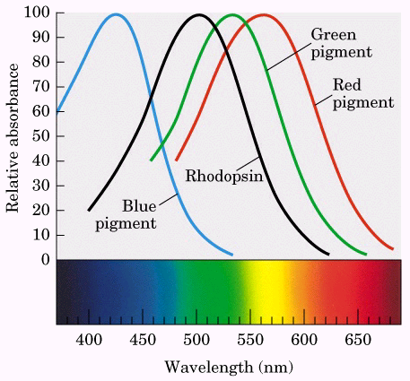 | 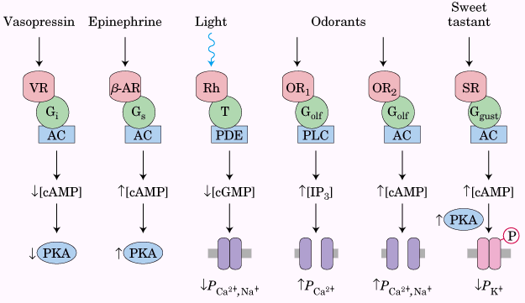

G protein-coupled serpentine receptor systems share several features
Of the approximately 105 genes in the mammalian genome, as many as 103 encode serpentine receptors, including hundreds for olfactory stimuli.
All well-studied transducing systems that act through heterotrimeric G proteins share certain common features. 1) the receptors have seven transmembrane segments, 2) a domain (generally the loop between transmembrane helices 6 and 7) that interacts with a g protein, and 3) a carboxyl-terminal cytoplasmic domain that undergoes reversible phosphorylation on several Ser or Thr residues. The ligand-binding site (or, in the case of light reception, the light receptor) is buried deep in the membrane and involves residues from several of the transmembrane segments. Ligand binding (or light) induces a conformational change in the receptor, exposing a domain that can interact with a G protein. Heterotrimeric G proteins activate or inhibit effector enzymes (adenylyl cyclase, PDE, or phospholipase C), which change the concentration of a second messenger. In the hormone-detecting systems, the final output is an activated protein kinase that regulates some cellular process by phosphorylating a protein critical to that process. In sensory neurons, the output is a change in membrane potential and a consequent electrical singal that passes to another neuron in the pathway connecting the sensory cell to the brain.
All of these systems self-inactivate. Bound GTP is converted to GDP by the intrinsic GTPase activity of G proteins, often augmented by GTPase activating proteins (GAPs) or RGS proteins (regulators of G-protein signaling).
Regulation of transcription by steroid hormones
The large group of steroid, retinoic acid (retinoid), and thyroid hormones exert their effects by a mechanism fundamentally different from that of other hormones: they act in the nucleus to alter gene expression. Steroid hormones (estrogen, progesterone, and cortisol), too hydrophobic to dissolve readily in the blood, are carried on specific carrier proteins from their point of release to their target tissues. In target cells, these hormones pass through the plasma membranes by simple diffusion and bind to specific receptor proteins in the nucleus. Hormone binding triggers changes in the conformation of the receptor proteins so that they become capable of interacting with specific regulatory sequences in DNA called hormone response elements (HREs), thus altering gene expression.
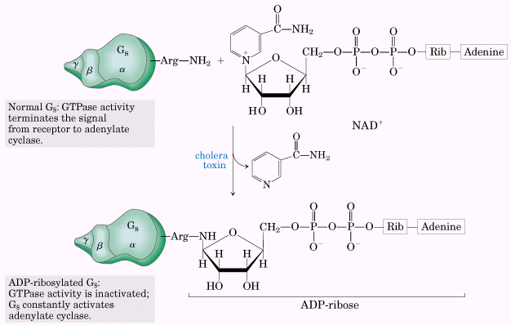

Regulation of the cell cycle by protein kinases
One of the most dramatic roles for protein phosphorylation is in the regulation of the eukaryotic cell cycle. Protein kinases and protein phosphorylation are central to the timing mechanism that determines entry into cell division and assures orderly passage through these events.
The cell cycle has four stages
Cell division in eukaryotes occurs in four well-defined stages. In the S (synthesis) phase, the DNA is replicated to produce copies for both daughter cells. In the G2 phase (G indicates the gap between division), new proteins are synthesized and the cell approximately doubles in size. In the M phase (mitosis), the maternal nuclear envelope breaks down, matching chromosomes are pulled to opposite poles of the cell, each set of daughter chromosomes is surrounded by a newly formed nuclear envelope, and cytokinesis pinches the cell in half, producing two daughter cells.
Levels of cyclin-dependent protein kinases oscillate
The timing of the cell cycle is controlled by a family of protein kinases with activities that change in response to cellular signals. These kinases are heterodimers with a regulatory subunit, cyclin, and a catalytic subunit, cyclin-dependent protein kinase (CDK). Animal cells have at least ten different cyclins (designated A, B and so forth) and at least eight cyclin-dependent kinases (CDK1 through CDK8), which act in various combinations at specific points in the cell cycle.
In a population of animal cells undergoing synchronous division, some CDK activities show striking oscillations. These oscillations are the result of four mechanisms for regulating CDK activity: phosphorylation or dephosphorylation of the CDK, controlled degradation of the cyclin subunit, periodic synthesis of CDKs and cyclins, and the action of specific CDK inhibiting proteins.
Regulation of CDKs by phosphorylation: the activity of a CDK is strikingly affected by phosphorylation and dephosphorylation of two critical residues in the protein.
Controlled degradation of cyclin: highly specific and precisely timed proteolytic breakdown of mitotic cyclins regulates CDK activity throughout the cell cycle.
Regulated synthesis of CDKs and cyclins: the third mechanism for changing CDK activity is regulation of the rate of synthesis of cyclin or CDK or both.
Inhibition of CDKs: specific protein inhibitors bind to and inactivate specific CDKs.
These four control mechanisms modulate the activity of specific CDKs that, in turn, control whether a cell will divide, differentiate, become permanently quiescent, or begin a new cycle of division after a period of quiescence.

Oncogenes, tumor suppressor genes, and programmed cell death
Tumors and cancer are the result of uncontrolled cell division. Normally cell division is regulated by a family of extracellular growth factors, proteins that cause resting cells to divide and, in some cases, differentiate. Some growth factors stimulate division of only those cells with appropriate receptors; other have a more general effect. Defects in the synthesis, regulation, or recognition of growth factors can lead to cancer.
Oncogenes are mutant forms of the genes for proteins that regulate the cell cycle
Oncogenes were originally discovered I ntumor-causing viruses, then later found to be closely similar to or derived from genes present in the animal host cells, called proto-oncogenes, which encode growth-regulating proteins. Proto-oncogenes can become oncogenes without a viral intermediary. The oncogenic defect can be in any of the proteins involved in communicating the “divide” signal. Oncogenes encode secreted proteins, growth factors, tramembrane proteins (receptors), cytoplasmic proteins (G proteins and protein kinases), and the nuclear transcription factors that control the expression of genes essential for cell division.
Mutant forms of the G protein Ras are common in tumor cells.
Defects in tumor suppressor genes remove normal restraint on cell division
Tumor suppressor genes encode proteins that normally restrain cell division. Mutation in one or more of these genes can lead to tumor formation. Unregulated growth due to defective tumor suppressor genes, unlike that due to oncogenes, is genetically recessive; tumor form only if both chromosomes of a pair contain a defective gene.
The effect of mutations in oncogenes and tumor suppressor genes is not all-or-none. In some cancers, perhaps in all, the progression from a normal cell to a malignant tumor involves the accumulation of mutations (sometimes over several decades), none of which alone is responsible for the end effect.
Apoptosis is programmed cell suicide
Many cells can precisely control the time of their own death by the process of programmed cell death, or apoptosis. Apoptosis also has roles in processes other than development. When an antibody-producing cell is found to be making antibodies against an antigen normally present in the body, that cell undergoes programmed death in the thymus gland---an essential mechanism for eliminating anti-self antibodies.
The regulatory mechanisms that trigger apoptosis involve some of the same proteins that regulate the cell cycle. The signal for suicide often comes from outside, through a surface receptor. Tumor necrosis factor (TNF), produced by cells of the immune system, interacts with cells through specific TNF receptors. These receptors have TNF-binding sites on the outer face of the plasma membrane and a “death domain” of about 80 amino acid residues that passes the self-destruct signal through the membrane to cytosolic proteins such as TRADD (TNF receptor-associated death domain).

